Maintain Don’t Gain

**Week 4**: Holiday Nutrition Tips

**Your eyes are bigger than your stomach …**

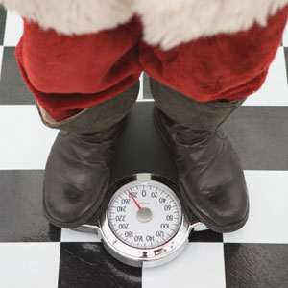Let’s face it – one thing we look forward to the most during the holidays is **food.**

Turkey dinner, mashed potatoes, gravy, eggnog, pies, sugar cookies, gingerbread …

According to the National Institute of Health, it is not a surprise that weight gain over the holidays is a large part of typical weight gain that adults accumulate over the years. While it may seem nearly impossible to enjoy Christmas dinners without eating anything “unhealthy,” the key to maintain and not gain is **balance.**

It’s not about cutting out everything unhealthy but finding *practical* and *realistic* ways to keep your sweet tooth in check and exhibiting *self-control*.

**Revising Recipes**

Many times, you can omit almost half of the sugar in a recipe. You can also increase the use of cinnamon, nutmeg, vanilla, and other sweet-tasting spices and flavorings.

To add in fibre, replace half of the fat in your recipe with applesauce, mashed bananas or baby-food prunes. Although these tricks help keep your recipes healthier, you still must keep the portion small. You can also replace oil with applesauce 1:1.

**Planning tips**

* 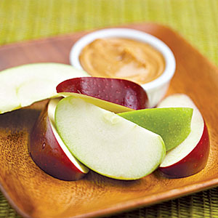**Decide ahead of time** what and how much you will eat and how you will handle social pressure ("No thank you, I'm too full.").
* **Bring your own** favorite low-sugar dessert to social functions. Some ideas are baked apples, angel cake, or fresh fruit.
* **Have a snack before holiday parties**. Choose a healthy snack with tons of *protein* before you head to a holiday party (edamame, almonds, hummus, apples and peanut butter). Protein staves off hunger for a long period of time.
* **Provide at least** **one healthier option per category** if you are cooking. For dessert, offer a fresh fruit option. For side dishes, offer a vegetable option instead of potatoes or rice. If you are going to a party, bring a healthy dish that you can enjoy.

**At the Party**

* **Share one portion of dessert** with someone else, and scrap off any high-fat whipped-cream topping or extra frosting.
* **Go for a walk** while dessert is out on the table. If you know someone else at the party who is trying to watch what they eat, ask them to join you to go for a walk.
* **Choose white meat** over dark meat. White, skinless turkey has 119 calories and 1 gram of fat whereas dark meat has 145 calories and 5 grams.
* 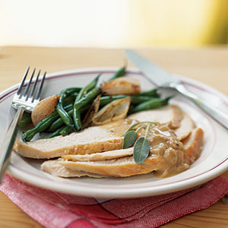**Pass on the bread**. When dining out, decline the bread and butter plate or limit yourself to just one piece.
* **Start out your meal with a salad or soup**. Skip the second helpings of stuffing, mashed potatoes and gravy; go for more vegetables instead.
* **Chew slowly**. Proper chewing also contributes to nutrient absorption and complete digestion allowing you to train the body to feel satisfied from smaller portion sizes, and helps your food taste more rich as you break down more of your food on your taste buds.
* **Lay off the booze**. Stay away from highly caloric cocktails like eggnog or mixed drinks. Hold something in your hand such as water, a glass of wine or juice.



Resources:

<http://planetgreen.discovery.com/>

<http://www.foodinsight.org/>

<http://www.diabetes.org/>