Maintain Don’t Gain

**Week 6**: Healthy Holiday Cooking

Preparing favorite dishes lower in fat and calories will help promote healthy holiday eating. Incorporate some of these simple-cooking tips in traditional holiday recipes to make them healthier.

* **Gravy** — Refrigerate the gravy to harden fat. Skim the fat off. This will save a whopping 56 gm of fat per cup.
* **Stuffing** — Use a little less bread and add more onions, garlic, celery, and vegetables. Add fruits such as cranberries or apples. Moisten or flavor with low fat low sodium chicken or vegetable broth or applesauce.
* **Turkey** – Enjoy delicious, roasted turkey breast without the skin and save 11 grams of saturated fat per 3 oz serving.
* **Green Bean Casserole** — Cook fresh green beans with chucks of potatoes instead of cream soup. Top with almonds instead of fried onion rings.
* **Mashed Potato** — Use skim milk, chicken broth, garlic or garlic powder, and Parmesan cheese instead of whole milk and butter. Keep the skins on.
* **Desserts** — Make a crustless pumpkin pie. Substitute two egg whites for each whole egg in baked recipes. Replace heavy cream with evaporated skim milk in cheesecakes and cream pies. Top cakes with fresh fruit, fruit sauce, or a sprinkle of powdered sugar instead of fattening frosting.



Resource: <http://www.mayoclinic.com/>

***Pork, White Bean, and Kale Soup***

This hearty soup is perfect for a chilly night and a sure way to impress your holiday guests with Christmas colours. Packed with protein, vitamins, and minerals, you won’t feel guilty about a second helping.

**Ingredients**

* 1 tbsp extra-virgin olive oil
* 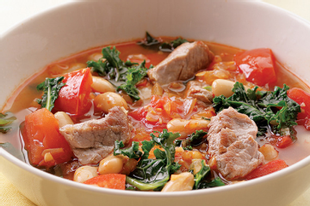1 lb pork tenderloin, trimmed, and cut into 1” pieces
* ¾ tsp salt
* 1 medium onion, finely chopped
* 4 cloves garlic, minced
* 2 tsp paprika, preferably smoked
* ¼ tsp crushed red pepper
* 1 cup white wine
* 4 plum tomatoes, chopped
* 2 cups reduced-sodium chicken broth
* 2 cups water
* 1 bunch kale, ribs removed, chopped (about 8 cups)

1 15-oz can white beans, well rinsed

**Instructions**

1. Heat oil in a Dutch oven over medium-high heat. Add pork, sprinkle with salt and cook, stirring once or twice, until no longer pink on the outside, about 2 minutes. Transfer to a plate with tongs, leaving juices in the pot.
2. Add onion to the pot and cook, stirring often, until just beginning to brown, 2 to 3 minutes. Add garlic, paprika and crushed red pepper (if using) and cook, stirring constantly, until fragrant, about 30 seconds. Add wine and tomatoes, increase heat to high and stir to scrape up any browned bits. Add broth and bring to a boil.
3. Add kale and stir just until it wilts. Reduce heat to maintain a lively simmer and cook, stirring occasionally, until the kale is just tender, about 4 minutes. Stir in beans, the reserved pork and any accumulated juices; simmer until the beans and pork are heated through, about 2 minutes.

|  |  |  |  |  |
| --- | --- | --- | --- | --- |
| **Nutritional Information (per serving 1 2/3 cup)** | | | | |
| **Calories** | **262** |  | **Monounsaturated** | **3 g** |
| **Protein** | **25 g** |  | **Cholesterol** | **45 mg** |
| **Carbohydrate** | **26 g** |  | **Sodium** | **300 mg** |
| **Total Fat** | **6 g** |  | **Fiber** | **7 g** |
| **Saturated Fat** | **2 g** |  | **Makes 6-8 servings** | |

Resource: <http://www.eatingwell.com/>

***Pomegranate Poached Pears***

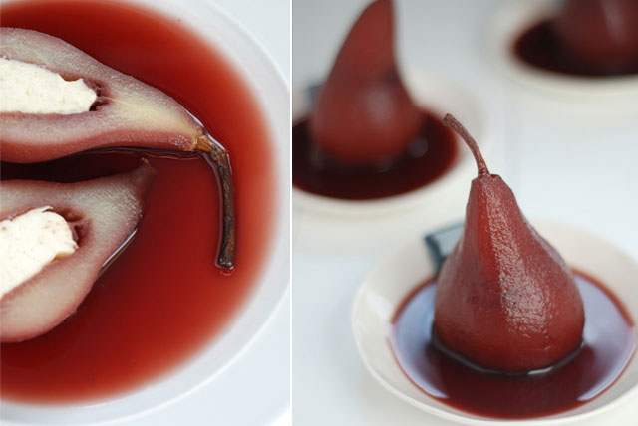

This super simple dessert is low-fat and makes a striking finale to any festive meal. Pears are simmered in a blend of tart pomegranate juice and sweet dessert wine. The pears are served with the reduced poaching liquid and a sprinkling of pomegranate seeds and toasted almonds.

**Ingredients**

* 4 ripe, firm Bosc pears
* 1 ½ cups pomegranate juice
* 1 cup sweet dessert wine, such as Muscatel or Riesling
* 2 tbsp sliced almonds
* ½ cup pomegranate seeds
* 4 tbsp reduced-fat sour cream, or low-fat plain yogurt
* 4 fresh or dried bay leaves, for garnish

**Instructions**

1. Peel pears, leaving them whole and stems intact. Slice off the bases so the pears will stand upright. Use an apple corer to remove cores, if desired.
2. Place the pears on their sides in a large saucepan or small Dutch oven. Pour pomegranate juice and wine over the pears. Bring to a simmer over medium-high heat. Cover, reduce heat to low and simmer gently until the pears are tender when pierced with the tip of a sharp knife, 30 to 45 minutes. Turn very gently once or twice as they cook so they color evenly. Using a slotted spoon, transfer the pears to a shallow bowl and set aside.

|  |  |  |  |  |
| --- | --- | --- | --- | --- |
| **Nutritional Information (per serving)** | | | | |
| **Calories** | **304** |  | **Monounsaturated** | **2 g** |
| **Protein** | **2 g** |  | **Cholesterol** | **6 mg** |
| **Carbohydrate** | **54 g** |  | **Sodium** | **17 mg** |
| **Total Fat** | **3 g** |  | **Fiber** | **6 g** |
| **Saturated Fat** | **1 g** |  | **Makes 4 servings** | |

1. Boil the poaching liquid over high heat until the sauce is reduced to ½ cup, 15 to 20 minutes.
2. Meanwhile, toast almonds in a small dry skillet over medium-low heat, stirring constantly, until light golden and fragrant, 2 to 3 minutes. Cool completely.
3. To serve, spoon 1 tablespoon sauce onto each of 4 dessert plates. Place a pear upright on each plate. Drizzle remaining sauce over each pear. Sprinkle pomegranate seeds around the pears and top with the almonds. Garnish each serving with a dollop of sour cream (or yogurt) and a bay leaf.

Resource: <http://www.eatingwell.com>