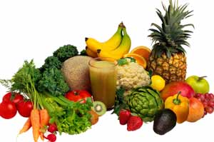
Eat Your Colors
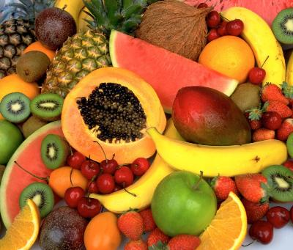
TIE BREAKER CHALLENGE
JULIE JOHNS’ TEAM | Wednesday,  Oct 12  (Start: 12pm) | Thursday,  Oct 13 | Friday,  Oct 14  (Finish: 12pm) | TOTAL  SERVINGS

- The challenge begins on Wednesday at 12pm [no earlier] and ends on Friday at 12pm [no later]. The winning team gets a SUBWAY LUNCH!

- Enter the total number of servings of FRUIT and VEGETABLES over the course of the tie breaker challenge. Please record after each day.

- 1 serving = ½ cup or 1 medium fruit or vegetable. Please use tip sheet to help you with ideas. The goal is 7-10 servings per day! Can you reach it?

