
Eat Your Colors

Eat your fruits and vegetables and help your team WIN POINTS over TWO WEEKS!


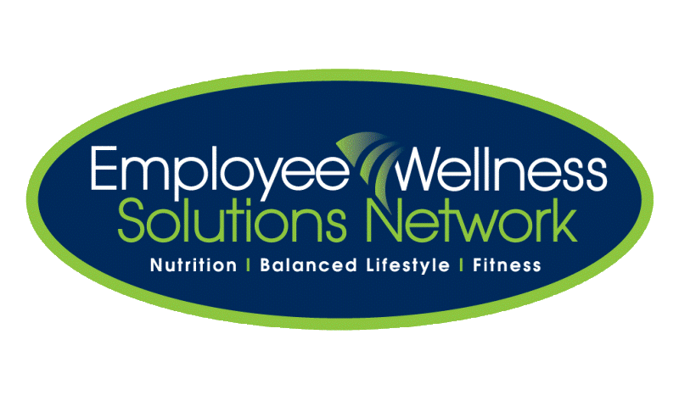
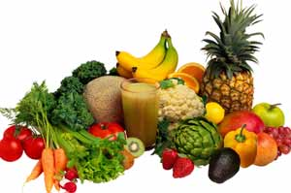

START DATE: Monday, Sept 26th
FINISH DATE: Friday, Oct 7th

Help your team WIN
A Subway Lunch!

Which Chemfil Team will accumulate the most points and WIN lunch?

