|  |  |  |  |  |
| --- | --- | --- | --- | --- |
| Ate1 Medium or  ½ Cup WHITE Vegetables | Ate at least two colors of vegetables for supper | Cooked with black beans | Ate ½ Cup GREEN Vegetables | Ate ½ cup green peppers |
| Ate ½ cup mushrooms | Ate 1 Medium or  ½ cup RED Vegetables | Ate at least two colors of vegetables for lunch | Steamed and ate  ½ cup broccoli | Ate ½ cup lentils |
| Ate ½ cup brussel sprouts | Ate 1 Medium or  ½ Cup PURPLE  Vegetable | Cooked with kidney beans | Ate 1 Cup GREEN Vegetables | Ate ½ cup turnip or squash |
| Ate 1 Medium or  ½ Cup PURPLE  Vegetables | Ate ½ cup kale | Ate 1 Medium or  ½ Cup WHITE  Vegetable | Ate ½ cup beets | Ate 1 Medium or  ½ Cup  ORANGE/YELLOW  Vegetables |
| Ate 1 Medium or ½ Cup  ORANGE/YELLOW  Vegetables | Ate ½ cup  cucumbers | Ate ½ cup chickpeas | Ate ½ cup or medium sweet potato | Ate ½ cup  cauliflower |

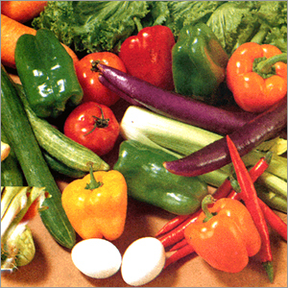As a team, consume your colors! Each member can choose the vegetables he/she would like to eat. ONE PERSON CAN ONLY CONSUME UP TO 5 tasks HIM/HERSELF. **It’s a team effort**!

Once consumed, cross off that vegetable task.

**Lines 1-3 = 10 points; “E” = 50 points; full card = 100 points**

*\*\*captains, keep track of points\*\**

***Best cumulative score from weeks 1 and 2 WINS!***

*****Captains, submit your scores on FRIDAY.***