|  |  |  |  |  |
| --- | --- | --- | --- | --- |
| Ate 1 Medium or  ½ Cup GREEN  Fruit | Ate1 peach | Ate two different colors of fruit today | Ate ½ cup berries | Ate ½ cup dried cranberries |
| Ate 1 banana | Ate 1 Medium or ½ cup RED Fruit | Ate ½ cup dried fruit | Ate 1 orange | Ate 1 Medium or  ½ Cup ORANGE/YELLOW Fruit |
| Baked with raisins | Ate 1 Medium or ½ Cup PURPLE  Fruit | Ate 1 Medium or ½ Cup RED  Fruit | Tried an exotic fruit [passion fruit, pomegranate, star fruit] | Ate ½ cup pineapple |
| Ate 1 Medium or ½ Cup RED  Fruit | Added two lemon slices to water | Ate ½ cup green  grapes | Ate ½ cup cantaloupe | Added two orange slices to water |
| Ate two different colors of fruit today | Cooked with lime juice | Ate ½ cup red grapes | Drank 1 cup  green tea | Ate 1 Medium or ½ Cup  GREEN Fruit |

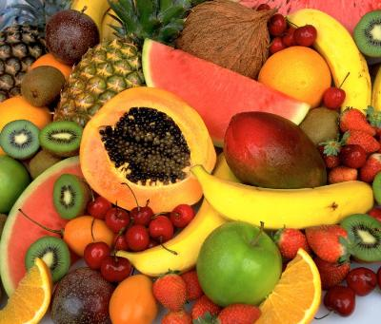As a team, consume your colors! Each member can choose the fruit he/she would like to eat. ONE PERSON CAN ONLY CONSUME UP TO 5 tasks HIM/HERSELF. **It’s a team effort**!

Once consumed, cross off that fruit task.

**Lines 1-3 = 10 points; “E” = 50 points; full card = 100 points**

*\*\*captains, keep track of points\*\**

Next week, enjoy eating some colorful vegetables!

***Best cumulative score from weeks 1 and 2 WINS!***

**