Tips for Picky Eaters
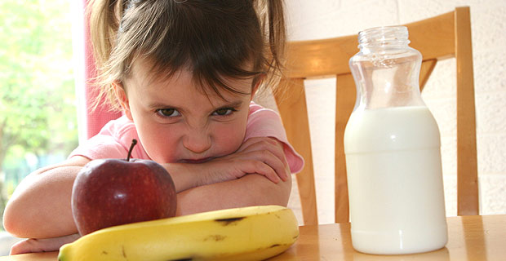
Now that you have leaned new techniques about healthy cooking ready to try out new recipes, the hardest audience to please is still your children. Remember these tips the next time you want to try a new cuisine or introduce a new food to your family table.
Picky Eater Dinner Ideas: http://www.momadvice.com/food/

- Part of a child’s normal development!
- If your child is growing and active, there is probably little to worry about.
- Even if they are not eating particularly well one day, keep into account the rest of the week that they at well.
- If you are still concerned, daily vitamins can work, but they are usually unnecessary.
- It’s normal for them to go on eating binges of one particular food.
- As long as your child is still adding value to their diet, there is little to worry about.
- If they are constantly and only eating junk food, be more conservative if it is not part of a well-rounded meal.
- But, do NOT buy in bulk for a toddler! As convincing as your child is that they will eat this forever, their loyalty to foods fluctuates easily and they change their minds very often.
- Keep snacking to a minimum towards dinnertime.
- If your child does not eat much during dinnertime, it could be because they are too full from the snacks (and drinks) prior to dinner.
- Remember, if your child is hungry during dinner, they will be more willing to eat new foods.
- Reintroduce rejected foods 10-15 times!
- Research shows that children need to be exposed to a new food usually between 10-15 times before they will accept it.
- Ex. If you child does not eat beans one night, give it a week and reintroduce the vegetable.
- Offer new foods at a minimum (1-2 times per week) with a small portion size (1 tbsp)
- Do not offer your child with too many new foods at one time or they may get overwhelmed and uninterested in the entire meal.
- Limit your exposure to 1-2 new foods per week.
- A portion size of 1 tbsp is enough to give them a taste and not waste food. If they like it, give them more!
- Do not equate food with behavior.
- You never want your child to think that eating is a symbol of esteem or love, or associate eating with negative feelings and punishment.
- Avoid praising your child for eating everything on the plate or punishing your child for not finishing their dinner.
- We want our children to have a healthy relationship with food and learn to exercise their own self-control towards their diet.
- Get your kids involved in the kitchen.
- May help them add new foods to their diet.
- Several benefits: math skills, understanding science, fine motor skills, and important bonding time as a parent.
- Gives them a sense of pride and ownership of the food they created.

Resource: http://www.momadvice.com/index.aspx

