Cooking with Pasta
Dry vs. Fresh
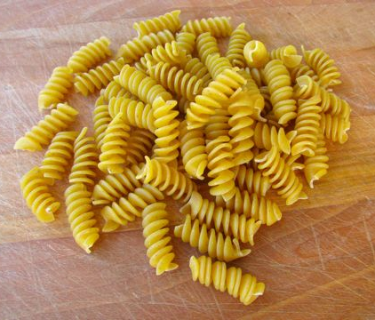
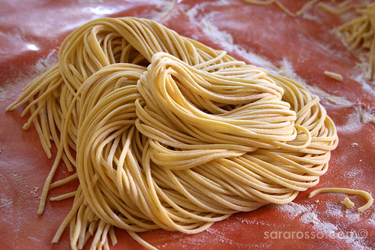
Dry: usually what recipes intend for you to use because sauces cling to it better. Best for heavy sauces, pasta salads, casseroles.

Fresh: more absorbent and works best with cream or cheese sauces. Best with light, delicate sauces. Store in fridge for up to 5 days.

Pasta Tips
- Use LOTS of water (at least 1 gallon per pound).
- Add enough salt to the boiling water to flavour the pasta.
- ‘Al dente’ = cooked completely through, yet firm enough to offer some resistance to your bite.
- Drain pasta in colander but do not rinse unless you’re using it in a casserole or pasta salad.
  - Why? You rinse off the starches and the sauce won’t cling to the pasta as easily.
- Tip: Reserve a small amount of the cooking liquid to add to your sauce.
  - Starches from the pasta will allow the sauce to cling to the pasta better.

Varieties of Pasta
- Pasta salads: short, thick tubes or shapes (macaroni, penne, fusili, rotini).
‘Al dente’ = cooked completely through, yet firm enough to offer some resistance to your bite.

- Heavy sauces: fettuccine, fusilli, linguine
- Light, smooth sauces: spaghetti, vermicelli
- Chunky, bite sized sauces: farfalle, fusilli, penne, macaroni, rigatoni, ziti, rotini.
- Soups: orzo, orecchiette,
- Casseroles: Tubes with thick walls or sturdy shapes (macaroni, penne, rigatoni, lasagne, fusilli)
  - Cook them for 2/3rds of the recommended time in water, then let them finish cooking in the oven.
- “ini” = smaller (spaghettini is thin version of spaghetti)
- “oni” = larger
Resource: http://www.foodsubs.com/Pasta.html

Cooking with Rice
Basmati
- Long and slender grain from India and Pakistan
- Best uses: pilafs, side dishes, plain boiled white rice
- Not ideal for puddings, burgers, or any dish where the rice is not displayed whole (use parboiled or short grained rice).
- Add some whole spices, nuts, dried fruit, veggies, beans or meats to make it into a main course.

Jasmine
- Can be interchanged with Basmati
- Slight jasmine aroma, firm and slightly stickier than Basmati
- From Thailand
- Best uses: pilafs, side dishes, plain boiled white rice (great for Thai curries and Vietnamese dishes)
- Not ideal for puddings, burgers, or any dish where the rice is not displayed whole.
Arborio
- Risotto
- Small kernels that develop a creamy consistency
- Exceptional ability to absorb flavours
- Best uses: risotto, stews, soup
- When cooked properly, the center of the grain should be hard while the rest of the grain is soft and creamy.

Wild Rice
- Not a rice but a grain native to North America
- Wild rice is seeds of a water grass
- Long, dark brown with black colourings
- Smoky, nutty flavour and chewy in texture
- Best use: main dishes, side dish, casserole, salads, stuffing
- High in protein, copper, fiber, folate, magnesium, niacin, phosphorus, B6 and zinc!

White Rice
- Milled rice with its husk, bran, and germ removed
- Done largely to prevent spoilage and extend storage life
- Often enriched with some nutrients stripped from it during its processing
- Significantly less iron and protein than brown rice.
- Best uses: plain boiled white rice, fried rice.

Resources: http://www.ricegourmet.com/, http://health.learninginfo.org/rice.htm

