Stir-Frying
Stir-Frying is a great route to fast, healthy cooking.
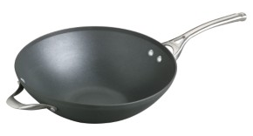
What do I need?

A wok is a large pan with a rounded bottom. Its curved edges allow you to push foods up the sides of the wok when you toss the ingredients together.

Orange Beef Stir-Fry
Key Stir-Fry Tips
- Cook on high heat with canola oil
- Cut veggies and meat into bite-size pieces before turning on the stove
  - Pat meat dry before adding to heated wok
  - Cut meat thinner so it will cook faster
- Fast frying
  - Cook meat first until browned but not fully cooked. Add meat again at the end with the sauce and vegetables
  - If you like your vegetables crunchy, add the “crunchy” vegetables at the very end (i.e bean sprouts, sugar snap peas).
- Make sure it is colourful! (Use an assortment of colours and textures of vegetables)
  - Onions, garlic, carrots, broccoli, sugar snap peas, bamboo shoots, water chestnut, bean sprouts, pineapples, mushrooms, bell peppers
- Experiment with different sauces but only add a reasonable amount
  - Sweet and Sour, Orange Marinade, Teriyaki, Spicy Thai
- Experiment with different rice and noodles
  - Jasmine rice, brown rice, vermicelli noodles, egg noodles, Shanghai noodles
Orange marmalade is the secret ingredient in this quick stir-fry. For variations, substitute chicken, shrimp, pork of tofu for the beef.

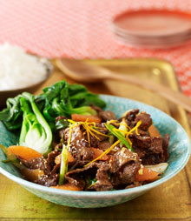
Ingredients
½ cup reduced-sodium chicken broth
1 tbsp cornstarch
2 tbsp reduced-sodium soy sauce
2 tbsp orange marmalade
1 tbsp oyster sauce
1 tbsp rice vinegar
1-2 tsp chile sauce
4 tsp canola oil
12 oz beef top sirloin, trimmed of fat, cut into ¼ inch strips
1 tbsp minced fresh ginger
1 large onion, slivered
1 small red bell pepper, diced
1lb broccoli florets (about 4 cups)

Instructions
- Combine ¼ cup broth, cornstarch, soy sauce, marmalade, oyster sauce, vinegar, chile sauce in a small bowl.
- Heat 1 tsp oil in a wok or large non-stick skillet over high heat. Add half the beef; stir-fry until browned, about 2 minutes. Transfer to a plate. Stir-fry the remaining beef in 1 tsp oil and transfer to plate.
- Add remaining 2 tsp oil to wok. Add ginger and fry for 10-20 seconds. Add onions, bell pepper and broccoli for about 1 minute. Pour remaining ¼ cup broth, cover and cook until vegetables are crisp tender (2-4 minutes).
- Push vegetables to the sides. Stir sauce mixture and add to wok until thick and translucent. Stir the vegetables into the sauce and return beef to the wok. Toss and coat. Serve immediately.

Nutritional Information (per serving)
Calories | 266 |  | Monounsaturated Fat | 5 g
Protein | 20 g |  | Cholesterol | 42 mg
Carbohydrate | 23 g |  | Sodium | 412 mg
Total Fat | 11 g |  | Fibre | 5 g
Saturated Fat | 3 g |  | Makes 4 servings (1 ¼ cups each)

Resources: http://www.your-healthy-eating-helper.com/index.html, http://www.eatingwell.com/

1 Recipe 3 Ways: Soup, Stew and Casserole
This method is a timesaving one that you won’t want to miss. From a Moroccan tagine, to a chicken soup, to an Irish stew, with a few exceptions, use this simple method to impress your family.

What do I need?
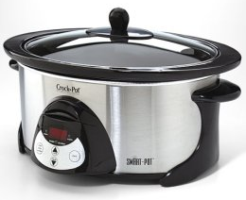
Crock pot (slow cooker): a countertop electronic cooking appliance that allows moist-heat cooking of simmering. This is done over many hours at a low temperature allowing for unattended cooking.

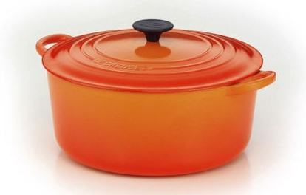
Dutch oven: Thick-walled (usually cast iron) cooking pot with a tight fitting lid that can be used on the stovetop and/or in the oven. It can retain heat, hold a lot of liquid, create moist-heat cooking environment and brown ingredients on stovetop.

Basic Instructions
- Heat a little oil in a large pot (Dutch oven).
- Soften onions and garlic.
- Add any vegetables.
- Add any protein such as fish, meat or beans until browned.
- Deglaze the pot with any liquid so that it just about covers everything (water, low sodium chicken broth, red wine, orange juice).
- Add desired herbs and seasoning
- Cover the pot and simmer and low heat.
Modifications
- For soups: add more liquid (an additional 1-2 cups).
- For stews: no change.
- For casseroles: Cover the pot and place it in the oven to bake at 350 degrees for 50-60 minutes. Make sure you use an oven-proof pot. If the dish is too watery once it is cooked, take the lid off and allow the water to evaporate. This is called reducing.
- If using a Crock Pot: Add all vegetables, protein, and juices in slow cooker. Cook on low for 10-12 hours or high for 5-6 hours.

Basic Stew Recipe – 4 Variations
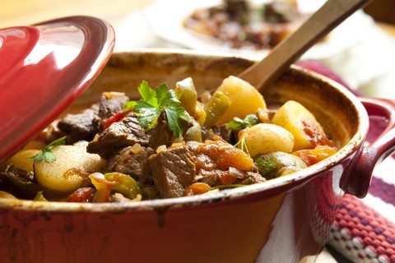
Ingredients
2 stalks celery
2 medium onions
2 carrots
Olive oil
1.5 tbsp flour
1 can diced tomatoes (14 oz)
Salt and Pepper

Then choose one of the following:
Beef and Ale (3 hours)
3 fresh or dried bay leaves
1 lb diced beef stewing meat
2 cups brown ale, Guinness or stout

Pork and Cider (2.5 hours)
3 sprigs fresh sage
1 lb diced stewing pork
2 cups medium-dry hard cider

Chicken and White Wine (1.5 hours)
3 sprigs fresh thyme
1 lb boneless, skinless chicken thighs
2 cups white wine

Lamb and Red Wine (2.5 hours)
3 sprigs fresh rosemary
1 lb diced stewing lamb
2 cups red wine

Instructions
Follow the Basic Instructions above.

Resources: http://www.your-healthy-eating-helper.com/index.html, http://www.jamieoliver.com/

Roasting
Roasting is easy, non-attention seeking, tastiest and has easy clean up! What more can you ask for?

What do I need?
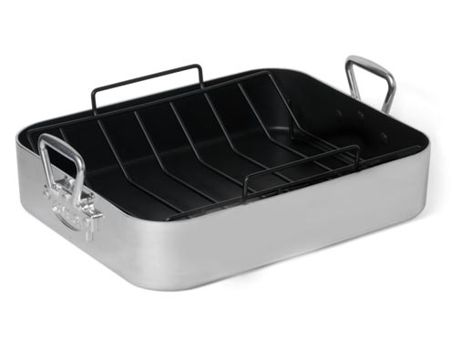
Roasting pan: designed to withstand very high heat, like that encountered in an oven. Depth is important where shallower pans cook foods quicker (with less browning), while deeper pans can roast meats and vegetables in their own juices as they cook.

Roasting Tips
Cooking Temperatures
- Low temperature (200 °F to 325 °F): Best when cooking large cuts of meat, turkey, and whole chickens. This slow-roasting technique allows for less moisture loss and a more tender product.
- Combination method: Using high temperature (400 °F) at the beginning or the end of the cooking process, with most of the cooking at a low temperature. This method produces golden-brown texture and crust but maintains more of the moisture than simply cooking at a high temperature the entire time.
- In either case, the meat is removed from heat before it has finished cooking and left to sit for a few minutes. The inside cooks further from the residual heat content, known as carry over cooking.
- Preferred method because sugars come out from meats and vegetables, making it naturally sweeter and crispier (without additional oil!)
- Roast your entire meal (potatoes, vegetables and meat in same pan)
- During roasting, frequently baste the surface with pan drippings or your own marinade. Basting refers to brushing the roast with juices or marinade every 25 minutes
- With joints of meat and poultry, the juices run clear when properly cooked.
- Vegetarian Option: Rinse and drain chick peas. Pat dry and leave them on a baking sheet to dry for an hour before you roast them in the oven so they turn out crispy! Great addition to vegetarian tacos and salads.

Roast Chicken Dinner
In tribute to everybody’s family favourite, Quarter Chicken Dinner from Swiss Chalet, this meal-pleasing roast is sure to satisfy the picky eaters!

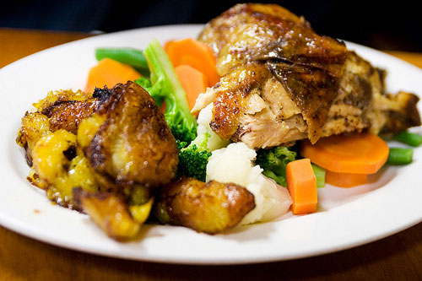
Ingredients
4 potatoes (unpeeled)
2 carrots (chopped in large pieces)
2 tbsp vegetable oil
1 tsp each salt and pepper
1 tsp dried thyme
4 chicken legs
1 cup frozen corn kernels
1 tbsp butter
Fresh parsley

Dipping Sauce:
½ cup chicken stock
¼ cup BBQ sauce

Optional: For an even healthier meal, add additional vegetables, substitute sweet potatoes for white potatoes, and use chicken breast instead of chicken leg.

Instructions
- Cut potatoes into ½ inch thick slices. Peel and cut carrots into large chunks. In a bowl, toss slices with half each of oil, salt, pepper, and thyme. Arrange potatoes and carrots ¼ inch apart on a greased baking sheet. Roast in 400 °F oven for 45 – 60 minutes. Flip half way through.
- Meanwhile, in a bowl, toss chicken with remaining oil, salt, pepper, and thyme. Roast alongside potatoes until juices run clear when chicken is pierced, about 45 minutes.
- Heat corn in microwavable dish or over stovetop. Mix butter until well incorporated.
- Garnish everything with parsley.

Nutritional Information (per serving with skin)
Calories | 631 |  | Cholesterol | 126 mg
Protein | 31 g |  | Sodium | 1 mg
Carbohydrate | 51 g |  | Fibre | 5 g
Total Fat | 34 g
Saturated Fat | 10 g |  | Makes 4 servings

Resources: http://www.your-healthy-eating-helper.com/index.html, http://www.canadianliving.com/

Recipes for Healthy Cooking for the Family

http://www.dairygoodness.ca/

http://familyfun.go.com/recipes/

http://www.eatingwell.com/

http://www.foodnetwork.com/healthy-eating/index.html

