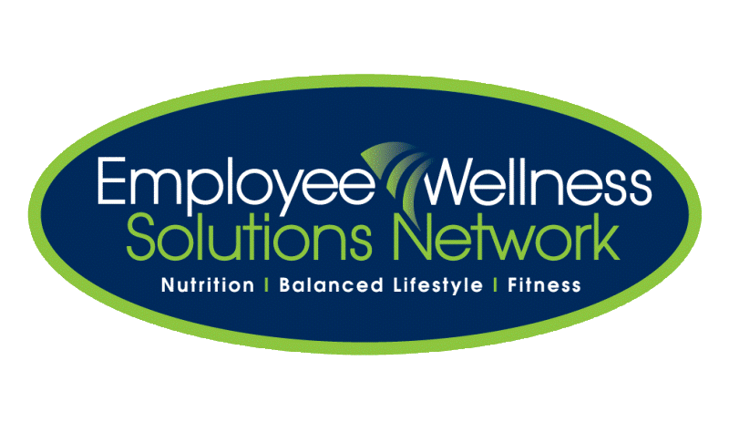
HEALTH FAIR Amway – SEPTEMBER 21, 22 & 23
SIGN UP sheets are located in the cafeteria. Sign up for your top 3 choices for appointments with the practitioners.
TUESDAY, September 21st
Kiosk Kick Off!

11:30 a.m. to 2:30 p.m.
Kiosks will be set up in The Old Store

WEDNESDAY SEPT. 22nd  2:00pm – 5:00pm  LOCATIONS TBA  Enjoy 15 minutes of bliss. This Healing Touch technique decreases tension headaches, mental confusion and increases clarity of thinking and seeing.  Cindy Palajac, Certified Healing Touch Practitioner  Inspired Health introduces a natural method of testing and eliminating food and environmental allergies from your body. Find out what it’s all about and have your natural health questions answered by Janet Brunswick R.N.C.P., R.h.A, R.P.N. and Alla Vallejo R.H.N., R.h.A.  Suzanne Frenette A.N.N. and ADP offers Nutritional Consultation as well as personal guidance, step by step through your nutritional changes. “When Diet Changes Everything Changes”.  Achieve your goals. Beth Sutherland is an Empowerment Coach specializing in helping individuals find the unconscious reasons, thoughts and patterns that prevent them from reaching their goals. Within 15 minutes she can discover the blockage and discuss the solution to unblocking.  Where do your feet hurt? Foot Reflexology can tell us a lot about our bodies and overall health. Cathy Brown-Swanton, a certified reflexologist, will provide a brief introduction to reflexology assessing tender areas of your the feet in order to discover ways of improving other areas of your bodies towards a more healthy, happy lifestyle.  Jazzercize – 12:00pm In The Old Store | THURSDAY SEPT. 23rd  11:00am – 2:00pm  LOCATIONS TBA  Back Health Screening How’s your spinal health? Book a 15 minute appointment with Dr. Scott Kay from Kay Chiropractic for a posture analysis, and spinal thermal scan.  Here’s your opportunity to release neck and shoulder tension. Book a 15 minute appointment with a Registered Massage Therapist, and experience all the benefits and convenience chair massage has to offer.  Sore feets, knees or hips? Foot Corrective Orthotics with Michelle Ray will help strengthen and correct the muscles and alignment in your feet so you can comfortably do the activities that you want, and need to do.  Detoxing Ionic Foot Baths This treatment provides a natural hydrotherapy detox and cleanse to rejuvenate your body and mind! Experience the benefits first hand by booking a 20 minute session with Kelly Ronsyn.  Ask the Homeopath! Meet Amanda Longland in a private setting to discuss questions/inquiries about your health. In a 15 minute consultation she will explain how homeopathy can benefit your specific health concerns.  Food Demos – 11:45, 12:15 & 12:30 In The Cafeteria
To allow everyone to take part, please sign up for your top 3 appointments. The final schedule will be posted with times of your appointments during the health fair week.

