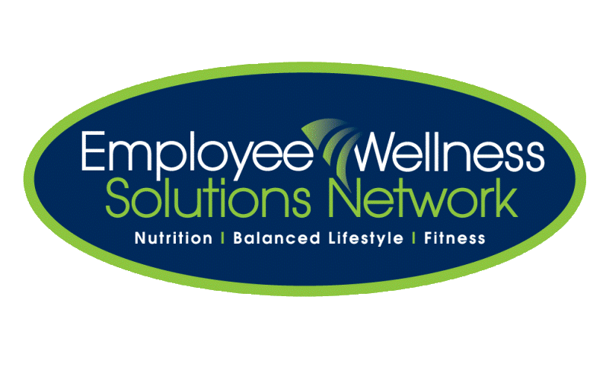
Natural Health Week at Quixtar – September 22-26

Come and experience a variety of holistic health approaches designed to decrease stress, boost your immunity, optimize your energy and reduce the aging process.
THURSDAY, September 18  Kick Off Lunch n’ Learn  “How To Really Change  Your Life”  with motivational speaker and author, Norman Barlow (PhD)  www.normanbarlow.com  11:45 and 12:45 p.m.(auditorium)  Come prepared to be inspired! | MONDAY, September 22nd  Body~Mind~Emotions~Spirit Reiki brings about a deep state of relaxation out of which comes healing, clarity, focus, stress reduction, a boost in the immune system, decreased physical pain, lessened anxiety and a sense of deep peace.  Reike Master Teacher Karen McKinnon will be providing 15 minute Reiki treatments  from 11:00 a.m. to 2:00 p.m.  Life Test “Mandatory” Information Session  11:45 a.m. or 12:45 p.m.  (for all those receiving a Life Test)  Life Assessment Systems goes into detail about this non-invasive test which measures your body’s internal functions and tells which minerals and vitamins your body may be lacking.  Life Tests to be done following the lunch n’ learns at 12:15, 12:30, 1:15, 1:30, 1:45, 2  Acupuncture Ken Hou, an acupuncturist, will be conducting 15 minute acupuncture appointments from  11-2pm. | TUESDAY, September 23rd  Spinal ThermoScans –  Back problems, headaches, pain????? Book an appointment with Chiropractor Sean Batte and let him give his professional opinion on what might be going on with your alignment with a thermoscan!  11:00 a.m. – 2:00 p.m.  Body~Mind~Emotions~Spirit Reiki brings about a deep state of relaxation out of which comes healing, clarity, focus, stress reduction, a boost in the immune system, decreased physical pain, lessened anxiety and a sense of deep peace.  Reike Master Teacher Karen McKinnon will be providing 15 minute Reiki treatments  from 11:00 a.m. to 2:00 p.m.
WEDNESDAY, September 24th  Wellness Wednesday  TWO healthy choice menus offered!!  Yoga with Shelley Wilkinson.  Classes will be held in the Auditorium.  11:45 or 12:45 p.m. (auditorium)  Please bring a mat or a towel with you. | THURSDAY, September 25th  Inspired Health  Alla Vallejo & Janet Brunswick will be providing 15 minute consultations about a natural method of testing and eliminating food and environmental allergies from your body from11 a.m. to 2 p.m.  Life Assessment Systems is providing 15 minute LifeTests.  This non- invasive test measures your body’s internal functions and tells us which minerals and vitamins your body may be lacking.  11:00 a.m. – 2 p.m.  Please make sure you attend one of the Life Test Lunch’n’Learns being held on Monday. | FRIDAY, September 26th  Smoothie Samplers  and  De-Stress kits

Sign up in the CAFETERIA by choosing your top 3 one-on-one events on the sheets provided. You have until Wednesday, Sept 17th. You will then be assigned an event (or two) and a time slot (s). There are no limits on the group events (keynote lunch n’ learn, YOGA, Life Test Information Session).

