**Week 6: Understanding the Digestive**



**System and Your Appetite**

**Introduction:** The appearance, smell, and taste of food, in addition to emotional states, have an impact on your digestion. The sight, smell, taste, and even thought of food will increase the release of hormones, fluids, and enzymes and increase muscular activity in your Gastro-intestinal (GI) tract.

**Sweet Vs Salty:** We naturally crave certain foods because our body needs the nutrients in them to function. This is healthy and normal. For example, the high flavour of sugar and fat encourages people to consume ample energy, especially in the form of foods containing sugars, which provide essential energy for the brain. Likewise, foods containing fats provide energy and essential nutrients needed by all body tissues and cells. The pleasure of salty foods encourages people to consume the right amounts of two very important minerals- sodium and chloride. Also, our dislike of bitter tasting foods helps to discourage our intakes of foods containing bitter toxins. The challenge is when we are craving something because we actually need it or because our emotions are out of whack or we are addicted to a certain chemical that has been added to the food (like MSG or aspartame). When you begin eating healthy, drinking enough water, exercising and cutting out processed foods, you will become closer to your natural state of hunger.

**The hunger-satiety mechanism:** when you eat food, hormones and enzymes will then trigger other hormones and chemicals to be released to slow down GI activity and limit food intake (tell you that you are full). We will go over these specific hormones in this lesson but first let’s take a look at how your digestive system works.

**A quick overview of your Digestive Tract:**

Your digestive tract is a flexible, muscular tube that begins in the mouth and goes through the throat, esophagus, stomach, small intestine, large intestine, and rectum to the anus, for a total length of about 26 feet. When you swallow something, it does not instantly “enter” into the body, it is in the tube that goes through your body. It is not part of the body until it passes through the wall of the digestive tract to enter body tissues.

The digestive system’s main job is to digest the food you consume into smaller components and then to absorb the nutrients, while leaving behind substances, like fibre, that help with passing the rest of the “junk” out of the body.

**The digestive tract works at two levels:**

1. **Mechanical digestion**: mechanical actions involved in digestion start in the mouth with chewing, then swallowing down the esophagus. Followed by mixing in the stomach, adding fluids, and then moving the contents through wavelike muscular contractions to the intestines. After digestion and absorption in the stomach and small intestine, wastes are excreted.
2. **Chemical digestion:** chemical digestion also begins in the mouth, where food is mixed with an enzyme in saliva (amylase) that begins to break down carbohydrates. Digestion continues in the stomach, where stomach enzymes and acid (released from pancreas) break down protein. Digestion then continues in the small intestine; there the liver and gallbladder contribute bile that binds and surrounds fat, and the pancreas and small intestine release enzymes that continue digestion so that absorption of nutrients can occur. Bacteria in the colon (large intestine) break down certain fibres.

**Digestive Tract Disorders**

Don’t spend a lot of time on this section. This is just additional information for people who may ask or want to know about these disorders. Go over food allergies/intolerances and Celiac disease.

**Inflammation of the Gut**

Ifyou only take one thing away from this lesson, it should be all the information presented in this section.

When food is being passed through your digestive tract it classifies them by what kind of inflammatory effect they have; the bad items contribute to inflammation, the good nutrients help prevent it. We are not talking about the inflammation that occurs when you feel “bloated” or what happens to your joints when you have arthritis. The inflammation we are talking about is the chemical reaction that happens within your blood stream and cells and is a major contributor to weight gain and disease. This inflammation is caused when oxygen free radicals attack cells in our bodies.

**Inflammation can be caused from:**

* Allergies to foods (even ones that you may not know you have)
* Certain reactions to bacteria
* Toxins in foods (a BIG one)
* The reaction of your liver to saturated and trans fats
* Toxins from cigarettes
* Stress

**Inflammatory responses can cause:**

* Hypertension (high blood pressure)

The combination of these conditions can lead to inflammation in your arteries leading to heart disease

* High cholesterol
* Insulin resistance (leading to Diabetes)
* Weight gain

**Inflammation in your Intestine**

Foods can cause inflammation of your intestinal wall through allergies, bacteria and other toxins (from bad highly processed foods we eat). When we are having an inflammatory reaction this makes us vulnerable to more toxins entering the bloodstream (because cells and tissues are inflamed and letting more through). Foods that don’t agree with your body trigger your body’s immune response to come and attack the foreign invader. Therefore, eating unhealthy food is like having a chronic infection that triggers your immune response, which then causes inflammation.

Another effect of inflammation is insulin resistance. Remember, one of your body’s major functions is to get glucose into your brain cells so they can function. Inflammation in the body stops sugar from getting to your brain, and you end up eating more high sugar foods which then increase inflammation again starting the cycle again.

The more inflammation you have in your body, the less efficiently you use your food calories, and the worse you feel. When you aren’t feeling your best, you tend to eat worse foods and with low energy it is hard to respond to the normal stresses of life, leading you back to that state of inflammation. You don’t want to be in this state of inflammation because of the reasons listed above as well as, inflammation can also damage your DNA and can lead to the development of cancerous cells. You are also prone to more infections because you body is using its defences on the toxins you are putting in your body rather than fighting off sickness.

When you have low energy and are stressed out it is very hard to win the battle of weight. This is what happens when you are out of control of your eating and stress levels:

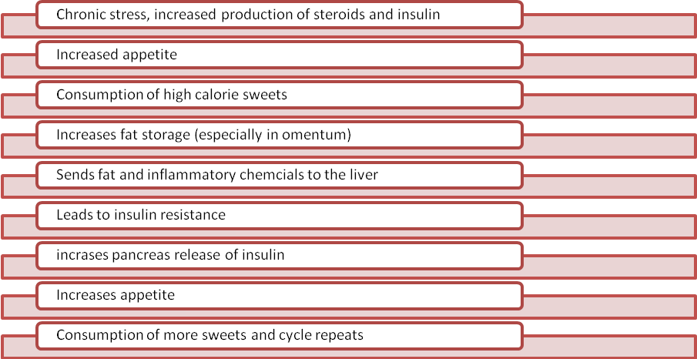

*(Source: YOU on a Diet-Roizen, OZ)*

**What can you do to End the Cycle?**

1. **Control what you put in your body.** It’s that simple. You need good food. Inflammation-reducing food. Antioxidants are great for helping prevent inflammation (Refer to antioxidant handout for ideas of what to eat). Antioxidant rich foods include brightly coloured fruits and vegetables.
   1. **Omega-3 Fatty Acids** found in fish oils, walnuts or in supplements are believed to help reduce inflammation (sources are listed on your “face the fats” handout from week 6)
   2. **Green Tea**: studies have shown that drinking three glasses of green tea a day can help reduce body weight and waist circumference, it also helps raise metabolism and contains antioxidants🡪 So drink up!
   3. **Turmeric:** this is a spice that contains a chemical called curcumin and can help reduce inflammation. Only add a small dose to food (1/8th of a teaspoon)
   4. Other foods that are thought to have anti-inflammatory effects: soybeans, flaxseed, whole grains such as rye, fruits, vegetables, rosemary, red wine, grapes, dark chocolate, garlic).
2. **Exercise**

Exercise as discussed throughout the program helps keep you young by aiding in digestion, controlling appetite, increasing metabolism, and giving you more energy. There is NO good reason that you should not be doing this favour for yourself and your body.

1. **Keep Regular**

Take note of how foods make you feel. If certain ones are causing you GI discomfort or indigestion try eliminating them for awhile and document how you feel. Make sure you are drinking enough water and eating enough fibre from fruits, vegetables, beans and whole grain products to ensure you are getting rid of the waste and toxins in your body on a regular basis. This is important because when we have too many toxins in the body, our bodies will hold onto fat in order to protect the body by diluting the toxins with fat.

1. **Stay away from refined sugars**

We discussed the negative effects of processed/refined sugars and products containing them already (See the vicious sugar cycle handout from week 5). Stick with naturally occurring sugars that are in fruits rather than mowing down on chocolate.

Now that you understand the digestive system and what affects it, let’s look at what controls appetite so you can learn to eat only when you are really hungry to ensure you reach or maintain a healthy weight.

**The Science of Appetite**

Appetite tends to come in two forms, the first being physiological signals from your body that make you hungry and the psychological or emotional desires that lure you to food.

**The Hunger Stop and Go Signals**

**The Stop Hormone: Leptin**

Leptin is a protein that is released by your stored fat. It is known as a satisfaction hormone and when stimulated it can turn your hunger off and turn your metabolism on to burn more calories by triggering CART (the command chemical in the hypothalamus discussed above). A major issue with leptin, however, is that it doesn’t always work at its full potential. The message that you are full created by leptin can be overruled by the pleasure center in your brain that may crave more chocolate or fatty foods even though you don’t need them. This is called leptin resistance and is a common problem in overweight people. Another form of leptin resistance is when your cells don’t respond to leptin’s messages. You can have both forms of leptin resistance and this is when your eating can become out of control, putting you in a vicious cycle of overeating because you don’t receive or respond to leptin signals.

**How can you make sure that leptin can do its job in your body so your brain will demand less food?**

EXERCISE!! Even just going for a thirty minute walk each day can help build cardio endurance, muscle, and help you get to your goal weight. Walking actually helps the body reach its internal normal weight where it can function efficiently. Remember your body does not want you to be overweight. When you are closer to your normal weight your cells become more sensitive and responsive to leptin, which is good news for killing your cravings!

**The GO Hormone: Ghrelin**

Ghrelin is the hormone that is released when your stomach is empty to tell you to eat. It does this by stimulating NPY the other command chemical located in your hypothalamus to urge you to consume energy. What is important to learn about this concept is that when you are dieting or restricting too many calories and not giving your stomach enough nutrients to digest, Ghrelin will continue to be released and will make you very hungry. This is one of the reasons why eating six small meals a day helps control your appetite. Your stomach is never empty for very long and you don’t have as many overwhelming hunger signals being sent to your brain.

**How do you can more control over your satiety systems?** With the FOODS you eat. Every time you put food in your body, different chemical reactions take place, and messages are sent to turn systems on or off. If you are sending your body something healthy like nuts that will provide nutrients and satisfaction, it will turn off your hunger signals when they hit your stomach. If you are putting in something like refined sugars, however, you will become hungrier because the nutrient content is VERY low. This goes for diet or fat free foods as well. If they aren’t providing you with calories or a little bit of protein or fat, they will likely make you hungrier than before you ate them!

**Psychological Signals**

Fear, anger, and worry can stimulate the hypothalamus to activate the autonomic nervous system, which then slows down the release of hormones, inhibits movement through the GI tract, and slows bowel movements by increasing the tone of muscles in the rectum. So, your frame of mind on a daily basis can affect your nutrition. Remember to try to keep stress levels down and think positive!!