**Week 4: Nutrition Labels, claims and organic food**

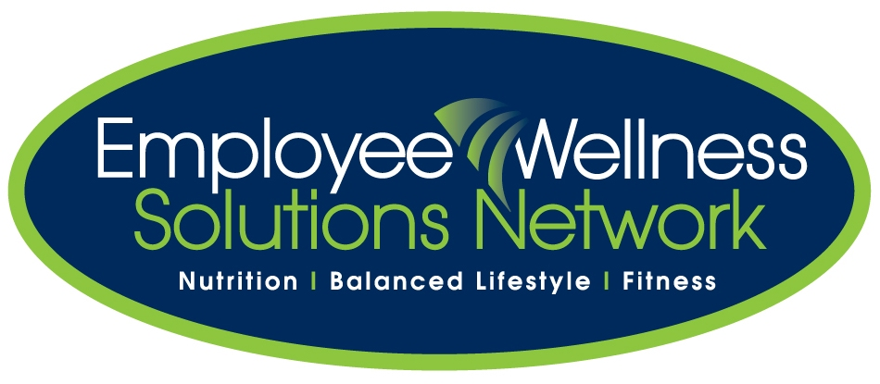

**BRING: food labels for show and tell!**

Successful dietary changes start with understanding how to read food labels. Without the basic knowledge, it’s virtually impossible to help manage food intake and control energy balance.

**Purpose of Nutrition Labelling:**

* To communicate product information between manufacturers and consumers.
* A practical guide that provides nutrient specific information about pre-packaged foods, which allows Canadians to differentiate between individual foods and make informed food-purchasing decisions.

**Who is responsible for Nutrition Labelling in Canada?**

* Through the Food and Drugs Act, Health Canada regulates the labelling of food products
* The Food and Drugs Act prohibits the labelling and packaging of a product that is false, or misleading.
* The Canadian Food Inspection Agency is responsible for administering and enforcing food labelling policies.

The nutrition label gives you information about the food’s nutritional value. Key pieces of information to look for on food labels are the:

* Ingredient List
* Nutrition Facts Table
* Nutrient Content Claims
* Health Claims
* Health Check

1. ***Ingredient List:***

Manufactures are required to list all ingredients in the product. The ingredients list begins with the ingredient that is the ***most abundant*** in the product and the others follow in descending abundance. For example, if a label lists the ingredients as sugar, water, and hydrogenated vegetable oil, then you know that sugar is the largest single ingredient used in the product followed by water and hydrogenated vegetable oil. The fewer number of ingredients, the better and more wholesome the product is.

* A good rule of thumb to go by is if there are twenty or more ingredients on the ingredient list and it sounds like a science experiment, stay away! The gigantic and often strange words listed on packages are the various concoctions used to colour, stabilize, emulsify, bleach, texture, soften, preserve, sweeten, add or cover smells, and flavour. To avoid these chemicals, stay away from highly processed packaged and canned foods. Stick to fresh grains, fruits, vegetables, lean meats, fish and dairy products.

**Hidden Ingredients:** Food manufactures know there’s an increased awareness with regard to the negative health effects of some fats, sugar and salt. Often, fats sugars and salts will be listed under different ingredient names. Here are some to watch for:

**Fats:** can be listed as fat, lard, shortening, oils (palm, coconut, hydrogenated vegetable), monoglycerides, diglycerides, or tallow.

**Sugars:** can be listed as sugar, honey, molasses, anything that ends in “ose” (dextrose, sucrose, fructose, maltose, lactose), dextrin, maltodextrin, high fructose corn syrup and other syrups. *In reality, all of these are sugars*. Quite often, you’ll see as many as five or six different types of sugar in one product. When you add all the sugars up, sugar is frequently by far the greatest source of calories.

**Salts:** can be listed as salt, MSG (monosodium glutamate), sodium, baking soda, baking powder, brine, kelp, or soy sauce.

***Ask participants to look at their food labels and find the hidden ingredients***

1. ***Nutrition Facts Table***

It is mandatory that a nutrition facts panel be included on most pre-packaged foods. The nutrition facts table must include ***calories and 13 core nutrients***. The core nutrients are saturated and trans fat, cholesterol, sodium, carbohydrate, fibre, sugars, protein, vitamin A and C, calcium, and iron.

This labelling excludes products such as fresh fruits and vegetables and single ingredient meat and poultry that are not ground.

***Ask participants to refer to their food labels and look at each section with you as you explain them.***

**Serving Size** is also a very important component of the Nutrition Facts Table. Values listed for the 13 nutrients are for the amount of the nutrient in the *specified quantity of food*. The serving size listed on the panel may be different from the actual amount that you eat. If all the numbers listed are based on half a cup of the food in question, and you normally eat 2 cups, factor that into the equation. For example, if the amount of carbohydrate is 6 grams per ½ a cup and you normally eat 2 cups, then you are really getting 24 grams of carbohydrate. Always check the serving size when comparing nutrient value between products.

**% Daily Values:** These are based on ***recommendations for a healthy diet*** and will help you determine what the nutrient values mean. The % Daily Value provides a quick overview of the nutrient profile of the food, allowing product comparisons based on more than one nutrient. It puts nutrients on the same scale (0% - 100% Daily Value) so you can quickly identify the strengths and weaknesses of a food product. Most people think this column shows the percent of each of the nutrients in a serving of the food. It really indicates the percent of daily recommendations of each nutrient in the serving of the particular food, based on a 2000-calorie diet. For example a product that contains 3g of fiber would represent 12% of your recommended daily value.

Tips to help you make better food choices when using food labels

See Food Label Tip Sheet

Remember that the values given in all categories are based on the serving size listed so be very aware of this when comparing products.

How many calories in one serving? – Look under calories or energy. Be aware of how many calories you require each day to maintain a healthy weight.

Fat: Total Fat is always listed. Usually saturated fat and trans fat are listed as well. The saturated fat should be less than 5 g; trans fat should be nothing but 0g. These fats are the “unfavorable fats” and should be limited! A better choice of fats is unsaturated. Unsaturated fat is sometimes missing on the label. To find out how much unsaturated fat you’re eating, perform this simple equation:

TOTAL FAT – SATURATED FAT – TRANS FAT = UNSATURATED FAT.

Unsaturated fat should be MORE than saturated fat.

If you want to know how many calories from fat are in the product (which you want to be under 30% calories from fat) you take fat calories (fat in grams x 9kcal) divided by the total food calories.

# of fat calories = fat grams listed on label x 9 kcal

% calories from fat = fat calories / total calories

Sodium/Potassium: As a general rule, eating less sodium (salt) is best! If the potassium amount is higher than the sodium amount (per serving), it is a favorable product. However, potassium is sometimes left out on a label. If it is listed, a great ratio is 2:1 for potassium to sodium. Sodium should be less than 200 mg on the label for a lower sodium diet! Try not to have any more than 2500 mg of salt per day. Less is better particularly if you’re on sodium restriction for high-blood pressure. So think twice about that canned soup that contains 800-900 milligrams of sodium per cup!

By improving your potassium-to-sodium balance, you can lower your risk of heart attack, stroke, osteoporosis, asthma, ulcers, stomach cancer, hypertension and other salt-linked killer diseases. The good news is that increasing the amount of potassium in your diet can help counterbalance the effects of high salt intakes. (National Institutes of Health 2009)

You can boost your potassium intake by choosing more whole unprocessed foods: fruits, vegetables, whole grains, fresh or frozen meat, poultry and fish, and low-fat or non-fat milk products.  These foods tend to be low in sodium as well.

Fibre : You’re making good choices if you get more than 3-4 grams of total fibre per serving. Foods providing more than 6 grams are very high sources of fibre.

Sugar: Products with less than 8g of sugar per serving are considered better products.

Protein: Products with at least 5g of protein per serving is excellent for foods such as grains and dairy. Foods like eggs, meat, poultry, and fish are much higher than 5g. All of these are excellent sources of protein!

1. Nutrient Content Claims – See Health Canada Resource Document

Ask participants to follow along in their Health Canada Handout for some of the following.

Nutrient Content Claims are based on the nutritive value of the product. An example would be “high source of fibre” on the food label. Some other words used in nutrient content claims are: low, less, reduced or lower, more, very high, light, source of, good or high source of, excellent or very high source of. Be careful of some of these claims. Light or “lite” can refer to the taste, texture or look not just calories, fat or sodium. Salt reduced products are not necessarily low in salt – they’re just lower than the original to which they are compared. Just because something is fat-free does not mean that it’s sugar free. Check the calorie count, sugar content, and the total carbohydrate per serving.

People often ask about the difference between butter and margarine. They are equal in fat content because both contain 100% fat, however, the fat is different. Butter contains primarily saturated fats. We want to avoid this type of fat because it tends to raise blood cholesterol levels. While margarine may also contain saturated fats, read the label to find out how much. The best margarines have 6 grams or more of unsaturated fat per 10 gram serving. To determine the total unsaturated fat content, add the values of poly and mono fat together. In general, “soft margarines” have less saturated fat than “hard” margarines. This makes them a healthier choice.

For more detail on content claims you can go to the Canadian Food Inspection Agency website at: [www.inspection.gc.ca](http://www.inspection.gc.ca)

1. **Health Claims**

Health claims are based on health and scientific criteria. Health Claims that are approved in Canada include:

1. A diet low in saturated fat and trans fat reduces the risk of heart disease
2. A diet with adequate calcium and vitamin D, and regular physical activity reduces the risk of osteoporosis
3. A diet rich in vegetables and fruit reduces risk of some types of cancer
4. A diet low in sodium and high in potassium reduces risk of high blood pressure.

Just remember to always look at the nutrition facts panel as well. A health claim may help reduce one disease, but the same food could be high in another nutrient that you are or want to be cautious about.

**5. Health Check:**

Some products contain a health check symbol. Health Check is a food information program developed and run by the Heart and Stroke foundation of Canada. There are a number of criteria for different food categories, depending on the important nutrient components of each food. For example, the criteria for bread focus on fat and fibre, while the criteria for milk products focus on fat and calcium.

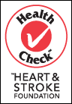

**PC Blue Menu:** Each product contains at least one of the following:

Lower fat

Lower Calories

High Fibre

Omega-3

Soy Protein

Lower Sodium

All of the blue menu products are made without hydrogenated oils which is also a great benefit. Like all products, it is still important to read the Nutrition Facts Panel and Ingredient list. Just because it is blue menu doesn’t mean you can eat bigger portions or down a whole bag of the blue menu cookies.

**PC Organics:** uses holistic agricultural practices when developing this line of products but they are not certified true organic. If you really want to buy organic food make sure is says “certified organic” somewhere on the label.

Now that you are armed with the knowledge of food labels and what to look for, it is time to start planning your menu!

**Organic Food**

Organic foods are plant products that are grown in enriched soil on which no pesticides, herbicides, or synthetic fertilizers have been used. Organic foods also include meat and dairy products that are not treated with drugs or hormones and are raised on natural feeds.

|  |  |
| --- | --- |
| **Benefits of Going Organic** | **Disadvantages** |
| Respects balance between nature and wetlands | May not look as “perfect” as modified products |
| Preserves soil and water | May be more expensive |
| Products are grown to strict standards | Some organic products may be less available during off seasons |
| Decreases consumption of harmful pesticides | Some organic manures may contain harmful bacteria (must wash your products well) |
| More flavourful and natural tasting | Non-organic farming may yield more from their crops |
| Helps you consume less drugs and hormones that are given to cattle and chickens |  |

**Is organic more nutritious?**

* This is difficult to determine duet to the many variable factors such as quality of soil, temperature and light. Some research has shown that organically grown food is usually higher in vitamin C. Organic food also has higher levels of iron and magnesium. Vitamin A, beta-carotene and B vitamins, have been shown to be somewhat comparable.
* If you are concerned with your toxicity level, going organic is the way to go. There is less toxins in organic food, period.