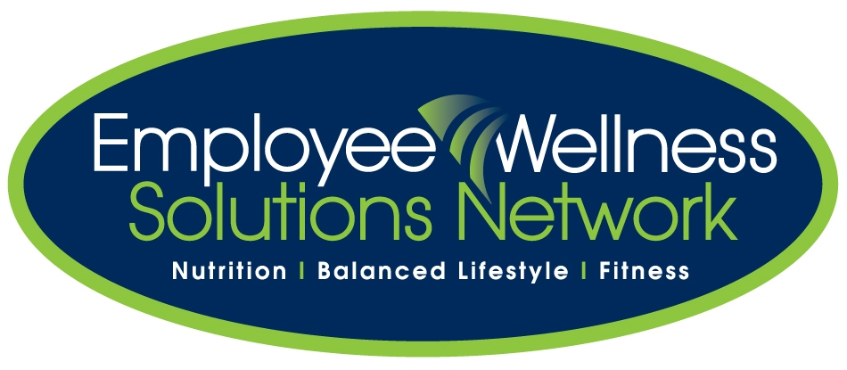
Top 10 Foods for Cholesterol
Source: Diet Motion
The first step for a heart-healthy diet is to reduce your intake of bad fats — especially saturated and trans fats. If cutting out bad fats isn’t enough to reduce your cholesterol, you may want to try to improve your diet and add special foods that can lower your cholesterol. Below is a list of the top 10 foods to help you lower your cholesterol.
- Apples. Apple pectin is a soluble fiber that helps draw cholesterol out of the system. The flavonoids (Quercetin) in apples act as a powerful anti-oxidant that seems to short-circuit the process that leads “bad” LDL cholesterol to accumulate in the bloodstream.
- Beans. Beans and vegetables are an excellent source of soluble fiber and high in vegetable protein. By properly combing beans with brown rice, seeds, corn, wheat you can create a complete protein. Properly combined beans become an excellent substitute for red meat protein that is high in saturated fat.
- Brown Rice. The oil in whole brown rice, not its fiber, lowers cholesterol. Brown rice can be combined with beans to form an inexpensive complete protein low in saturated fat. In addition, this whole grain also supplies good doses of heart-healthy fiber, magnesium and B vitamins.
- Cinnamon. A study published in the journal Diabetes Care found that half a teaspoon of cinnamon a day significantly reduces blood sugar levels in people with type 2 diabetes. It also reduces triglyceride, LDL, the bad cholesterol and the total cholesterol level.
- Garlic. Garlic contains the chemical allicin, which has been shown to kill bacteria and fungi, and alleviate certain digestive disorders. It also lowers the blood clotting properties of blood. But the most notable attention garlic has received over recent years is its possible usefulness in lowering cholesterol levels.
- Grapes. Flavonoids in grapes protect LDL cholesterol from free radical damage and reduce platelet clumping. The LDL lowering effect of grapes comes from a compound that grapes produce normally to resist mold. The darker the grape, the better [darker color = antioxidant properties].
- Oats. Oatmeal contains soluble fiber, which reduces your low-density lipoprotein (LDL), the “bad” cholesterol. Five to 10 grams of soluble fiber a day decreases LDL cholesterol by about 5 percent. Eating 1.5 cups of cooked oatmeal provides 4.5 grams of fiber — enough to lower your cholesterol.
***goo-ey consistency of the oats as it soaks up water pulls the LDL cholesterol out of the system. That’s why oats are a power food for lowering cholesterol and maintaining a healthy weight!
- Salmon. The major health components in salmon include: Omega 3 fatty-acid and protein. These components have a favorable cardiovascular effect. The recommendation is that people include at least two servings of fish/week, particularly fatty fish (salmon, tuna, mackerel, sardines, anchovies and herring), in their diets.
- Soy Products. The top health promoting components in soybeans are isoflavones and soluble fiber. Isoflavones act like human hormone that can lower LDL cholesterol and raise HDL cholesterol. All soy products (soybeans, soy nuts, tofu, tempeh, soy milk, etc.) are complete proteins.
- Walnuts. Walnuts can significantly reduce blood cholesterol because they are rich in polyunsaturated fatty acids. Walnuts also help keep blood vessels healthy and elastic. Almonds appear to have a similar effect, resulting in a marked improvement within just four weeks. A cholesterol-lowering diet with a little less than 1/3 of a cup of walnuts/day may reduce LDL cholesterol by 12 percent.

