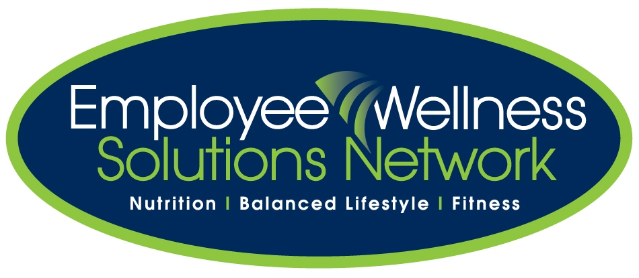
Metabolism Consultant Notes:
Top Ways to Boost Metabolism
1. Eat little and often
Small and regular meals throughout the day will keep your metabolism high. If you eat the same amount of food in just one or two large meals as you do in five or six mini-meals and snacks you will burn fewer calories. This is because your metabolism slows down between meals. Never skip meals to save calories. Having a low-calorie snack will work much better and will also stop you falling ravenously on the nearest chocolate bar later in the day.
2. Eat breakfast
Your metabolism slows down overnight. When you have been through a period of more than eight hours without eating you need food to get your metabolism going again. So have breakfast as soon as you can after you wake up. If you're not a breakfast person take something healthy with you when you leave the house and have it is soon as you can face it. It's not great for your weight loss plans to have to boost your metabolism with a mid morning cookie or cake.
3. Eat enough
If you eat too few calories, your metabolic rate will automatically drop. This is a self preservation mechanism, which kicks in when your body thinks you are starving. The safest bet is to eat about 250 calories less than you need at the sedentary level and to take 250 - 500 calories of exercise each day to give a steady weight loss of between one and two pounds a week.
4. Eat Lean Protein
It takes more energy for the body to digest protein than carbohydrate or fat. Studies have shown that people who eat a high-protein diet burn more than twice as many calories in the hours following their meal as those eating a high carbohydrate diet. While the safety of high-protein diets can be disputed, it does make sense to include some lean protein as part of each meal.
5. Eat Fibre
Food with lots of fibre also gives your thermic metabolism a boost. High-fibre foods like beans, fruit, vegetables and whole grains simply take longer to digest and therefore help burn more calories.
6. Spice up your food
Spicy foods (especially chilli) raise the metabolism by as much as twenty-five per cent for a few hours after eating. So eat hot and spicy food a bit more regularly and see if this helps you. Just go easy on the refried beans and guacamole if you decide to go Mexican!
7. Drink Coffee
Caffeine speeds up your heart rate and the faster your heart rate the more calories you burn. Not great if you have heart problems or difficulty getting to sleep however!
8. Drink Green Tea
The phytochemicals in green tea are supposed to raise metabolism slightly by causing your brain and nervous system to run more quickly. Although not many sizable and conclusive studies have been done on this to date, drinking green tea rather than milky coffee or other calorie-laden beverages will definitely help you lose weight!
9. Get active
Aerobic exercise for more than thirty minutes not only burns calories but also keeps your metabolism high for several hours afterwards. The best time for exercise is in the morning as it will help kick start your metabolism for the day. If you can do 30 to 60 minutes of aerobic exercise almost every day your metabolism will soar. Interval training would help even more.
10. Walk it off
If you prefer to take light exercise, try going for a walk after lunch or dinner. This boosts the rise in metabolism you get after eating. No strenuous exercising on a full stomach though.
11. Build those muscles
Muscles burn calories even when you're resting. For every pound of muscle you add, you burn about 50 extra calories a day without taking any more exercise. So it's a great idea to include some resistance or weight training in your exercise regime. Twenty minutes three times a week is enough to make a big difference in your metabolic rate as well as the shape of your body.
12. Go hot or cold
Any extremes of temperature you experience will help raise your metabolism by up to 20 percent as the body attempts to cool you down or raise your temperature. Make sure it's safe for you to go in the sauna or on the arctic expedition though before you try this one. You could have a go at keeping your home a few degrees cooler than is comfortable for sitting around in winter and restrict the air conditioning to the very hottest days in summer. In the winter it will help you get up and get moving and in summer encourage you to go to the pool to cool off!
13. Drink Iced Water
Another trick is to drink a glass of iced water a few times a day. You'll raise your metabolism just by having to bring the water up to body temperature. Drinking water is required anyway, of course, to keep your bodily functions working smoothly (including your metabolism).
14. Watch the alcohol
On top of the empty calories that alcohol contains, it also has a dehydrating effect, which slows down your thermic metabolism. Alcohol tends to inhibit the process of metabolizing fat too, which can lower your basal metabolism. And there's not much chance of you wanting to exercise after all that booze so it'll have an effect on your activity metabolism too. Bad news all round!
15. Take up yoga
The chemical processes which comprise your metabolism are regulated by the endocrine system, especially the thyroid. Yoga has many postures which have a powerful twisting and compressing effect on the endocrine organs, strengthening and stimulating them and this can help to regulate and boost your metabolism.
Top 10 Power Foods to Boost Metabolism
1. Water! A new study seems to indicate that drinking water actually speeds up weight loss. Researchers in Germany found that subjects of the study increased their metabolic rates (the rate at which calories are burned) by 30 percent after drinking approximately 17 ounces of water. Water is also a natural appetite suppressant that banishes bloat as it flushes out sodium and toxins. Drinking enough water will also help keep you from mistaking thirst for hunger. So drink up!
2. Green Tea! Studies show that green tea extract boosts metabolism and may aid in weight loss. This mood-enhancing tea has also been reported to contain anti-cancer properties and help prevent heart disease. It’s also a trendy drink among weight-conscious celebrities.
3. Soup! Eat less and burn fat faster by having a bowl of soup as an appetizer or a snack. According to a Penn State University study, soup is a super appetite suppressant because it’s made up of a hunger-satisfying combination of liquids and solids. In the study, women chose one of three 270-calorie snacks before lunch. Women who had chicken and rice soup as a snack consumed an average of 100 fewer calories than those in the study who opted for a chicken and rice casserole or the casserole and a glass of water.
4. Grapefruit! The grapefruit diet is not a myth. Researchers at Scripps Clinic found that participants who ate half a grapefruit with each meal in a 12-week period lost an average of 3.6 pounds. The study indicates that the unique chemical properties in this vitamin C-packed citrus fruit reduce insulin levels, which promotes weight loss. NOTE: If you are taking medication, check with your doctor about any potentially adverse interactions with grapefruit.
5. Apples and Pears! Overweight women who ate the equivalent of three small apples or pears a day lost more weight on a low-calorie diet than women who didn’t add fruit to their diet, according to researchers from the State University of Rio de Janeiro. Fruit eaters also ate fewer calories overall. So next time you need to satisfy a sugar craving, reach for this low-calorie, high-fiber snack. You’ll feel full longer and eat less.
6. Broccoli! Study after study links calcium and weight loss. Broccoli is not only high in calcium, but also loaded with vitamin C, which boosts calcium absorption. This member of the nutritious cabbage family also has plenty of vitamin A, folate and fiber. And, at just 20-calories per cup, this weight-loss superfood not only fights fat but also contains powerful phytochemicals that boost your immunity and protect against disease.
7. Low-Fat Yogurt! Dairy products can boost weight loss efforts, according to a study in the April issue of Obesity Research. People on a reduced-calorie diet who included three to four servings of dairy foods lost significantly more weight than those who ate a low-dairy diet containing the same number of calories. Low-fat yogurt is a rich source of weight-loss-friendly calcium, providing about 450 mg (about half the recommended daily allowance for women ages 19-50) per 8-ounce serving, as well as 12 grams of protein.
8. Lean Turkey! Rev up your fat-burning engine with this bodybuilder favorite. Countless studies have shown that protein can help boost metabolism, lose fat and build lean muscle tissue so you burn more calories. A 3-ounce serving of boneless, skinless lean turkey breast weighs in at 120 calories and provides 26 grams of appetite-curbing protein, 1 gram of fat and 0 grams of saturated fat.
9. Oatmeal! This heart-healthy favorite ranks high on the good carb list, because it’s a good source of cholesterol-fighting, fat-soluble fiber (7 grams per 3/4-cup serving) that keeps you full and provides you with the energy you need to make the most of your workouts. Just be sure to choose steel cut or rolled oats, not instant oatmeal, to get your full dose of vitamins, minerals and fiber.
10. Hot Peppers! Eating hot peppers can speed up your metabolism and cool your cravings, researchers at Laval University in Canada found. Here’s why: Capsaicin (a chemical found in jalapeno and cayenne peppers) temporarily stimulates your body to release more stress hormones, which speeds up your metabolism and causes you to burn more calories.
Top 5 Foods that Sabotage Metabolism
1) SUGAR:-Eating too much sugar overloads your body and causes your blood sugar levels to rise rapidly. This in turn makes your body go into conservationmode meaning that you will store extra fat and burn less calories. To make sure this does not happen you need to reduce your intake of refined sugars as much as possible. That means cutting down on the candy, chocolate, cakes and cookies as much as possible. If you still want something sweet try eating some fruit. Unlike refined sugars, most fruits contain fructose which does not cause your blood sugar levels to rise.
2) WHITE BREAD:-White bread is made from wheat flour which then has the bran and germ removed. White bread is bleached to remove any yellow colour which destroys many of the vitamins contained in the wheat plus it is full of sugar. This means that it is very easily digested, has a low nutritional value and is low in dietary fiber. When processing white bread your body burns very few calories and it also causes your blood sugar levels to rise. I know you have probably heard it many times before but by substituting white bread for a wholemeal variety you can really boost your metabolic rate. Wholemeal bread is harder to digest (so burns more calories whilst being processed), has a greater nutritional value and most importantly does not cause your blood sugar levels to rise in an uncontrolled way.

3) FRIED FOODS:-Like white bread, fried foods are very low in nutritional value and easy to digest. They are also very high in calories and full of saturated fats. Saturated fats are solid at room temperature, generally come from an animal source, make your body produce more cholesterol and slow down your metabolic rate. You really need to avoid fried foods for the sake of both your metabolism and your health. Next time you are craving fried food such as a beef burger why not replace this with a slice of grilled, lean beef on brown bread? Not only will it be better for you but I think it tastes a lot nicer too.

4) PROCESSED FOODS:-Processed foods include ready meals, crisps and chocolate bars. They are very popular because they are quick and convenient but guess what? The vast majority are also lacking in nutritional value, contain dangerous trans fats and are high in chemical preservatives. Again this combination of factors in processed foods means that they reduce your metabolic rate. I know that it can be very tempting to opt for processed foods when you want something to eat after a long, hard day but your body will really thank you if you take the time to cook something healthier. If time really is an issue then why not try cooking in large batches and freezing the leftovers? This will mean that you will still have access to quick, convenient foods when you are in a rush BUT they will be healthy.

5) ALCOHOL:-Alcohol is full of sugar and calories which (as you probably know by now) restrict your metabolic rate. Alcohol is also known to have a dehydrating effect .If you are not fully hydrated your metabolism does not work as effectively. Moderate consumption of alcohol is not going to have a huge effect on your hydration levels but excessive consumption will. For most of us there are going to be times when we over indulge on alcohol so I am not going to advise you to give up alcoholic beverages. However, you should make an effort to reduce the amount you are drinking.

