**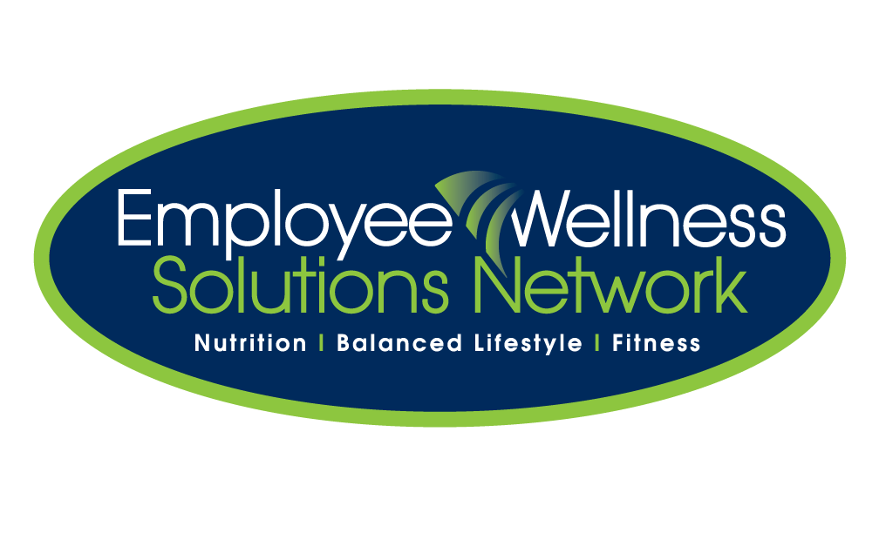****Walking Tour of Ontario NOTES:** 

**Supplies needed:** fish bowl [or glass container], map of Ontario [specific to your city], ballots, moveable game piece/marker for map, putty, pencils/pens, table, incentive prize for winning team.

**TO DO:** Ensure table, fish bowl, extra ballots, pens/pencils are arranged on table in a high traffic area. Post map and banner on wall [use putty].

**SUGGESTIONS:** Suggested timeframe is 3-4 weeks. Incentive prize for winning team [farthest around tour] or individual prize draws at the end of each week.

**OBJECTIVE:** Individuals are encouraged to accumulate as many steps or time as possible. All completed ballots are entered into the fish bowl for prizes. Everyone works toward the same goal of moving across the country. If you prefer a team A vs team B campaign, shorten the course on the map or make the race more applicable to kms travelled instead of steps/time [make the distances relative to who and how many are participating].

**CHECKLIST OF PROMOTION:** refer to initiative checklist grid for promotional dates and tasks.

**CHECKLIST TO PREP INITIATIVE:**

* Task your promotion dates, materials, emails to staff, reminder emails, poster mounting, etc…
* Create ballot slide specific to your initiative [or leave generic to use for future campaigns].
* Save slide as a JPG.
* Cut and paste JPG slide into word and make enough copies to fill the page [see example that is uploaded].
* Make enough copies of ballots for each employee to have one to start. The ballots fill up quickly so make enough for the duration of the campaign.
* On the map, outline the course with black marker and the post in a high traffic area. Determine the distance from each major city to the other and mark those distances on the map [cut out the distance totals and putty on map].
* Designate wellness committee member [or consultant] to tally the ballots [steps] each week and move the game piece across the map accordingly.
* Winning team is the one that gets the farthest around the course at the end of the timeframe.
* If teams are to be made, designate captains. Wellness committee members will discuss the best way to make teams [WC members as captains, departments against each other, random draw, etc…].