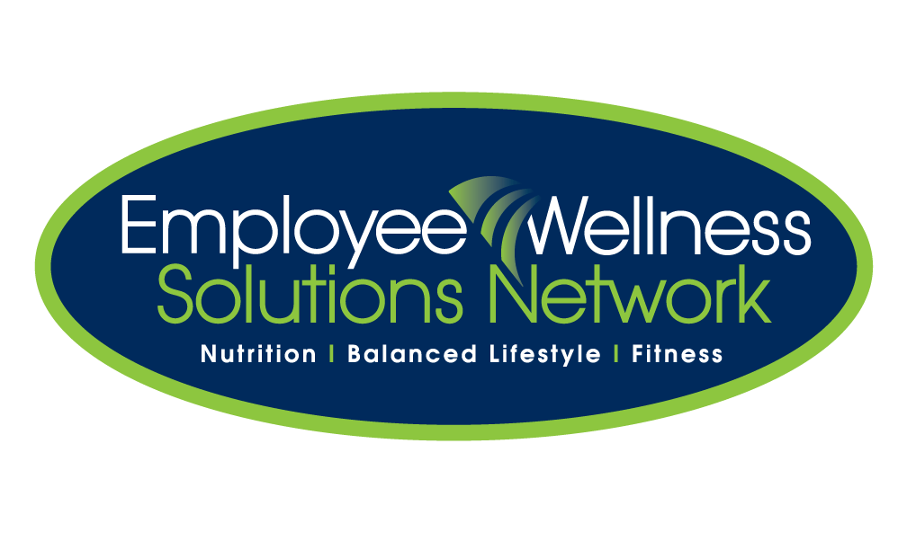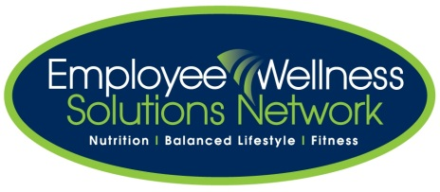**Walking Tour of Canada NOTES:**



**Supplies needed:** fish bowl [or glass container], map of Canada, ballots, moveable game piece/marker for map, putty, pencils/pens, table, incentive prizes for draw.

**TO DO:** Ensure table, fish bowl, extra ballots, pens/pencils are arranged on table in a high traffic area. Post map and banner on wall [use putty].

**SUGGESTIONS:** Suggested timeframe is 3-4 weeks. Incentive prize draws done weekly.

**OBJECTIVE:** Individuals are encouraged to accumulate as many steps or time as possible. All completed ballots are entered into the fish bowl for prizes. Everyone works toward the same goal of moving across the country. This isn’t a team A vs team B campaign.

**CHECKLIST OF PROMOTION:** refer to initiative checklist grid for promotional dates and tasks.

**CHECKLIST TO PREP INITIATIVE:**

* Task your promotion dates, materials, emails to staff, reminder emails, poster mounting, etc…
* Create ballot slide specific to your initiative [or leave generic to use for future campaigns].
* Save slide as a JPG.
* Cut and paste JPG slide into word and make enough copies to fill the page [see example that is uploaded].
* Make enough copies of ballots for each employee to have one to start. The ballots fill up quickly so make enough for the duration of the campaign. Give extras to the wellness committee members and the consultants.
* On the map, outline the course with black marker and the post in a high traffic area. Determine the distance from each major city to the other and mark those distances on the map [cut out the distance totals and putty on map].
* Designate wellness committee member [or consultant] to tally the ballots [steps] each week and move the game piece across the map accordingly.
* Teams are to be made. Wellness committee members will discuss the best way to make teams [WC members as captains, departments against each other, random draw, etc…]
* Suggested: at the end of each week.