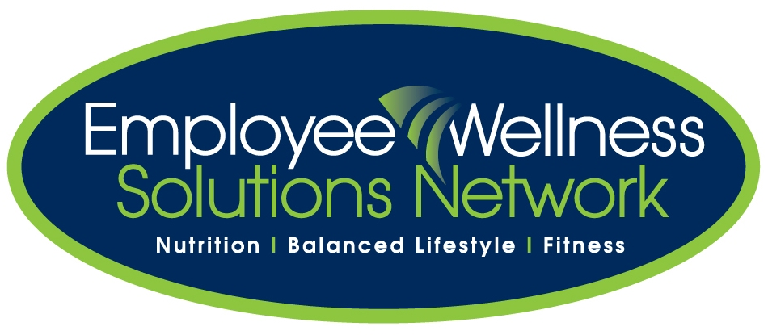

**Progression Report**

**for**

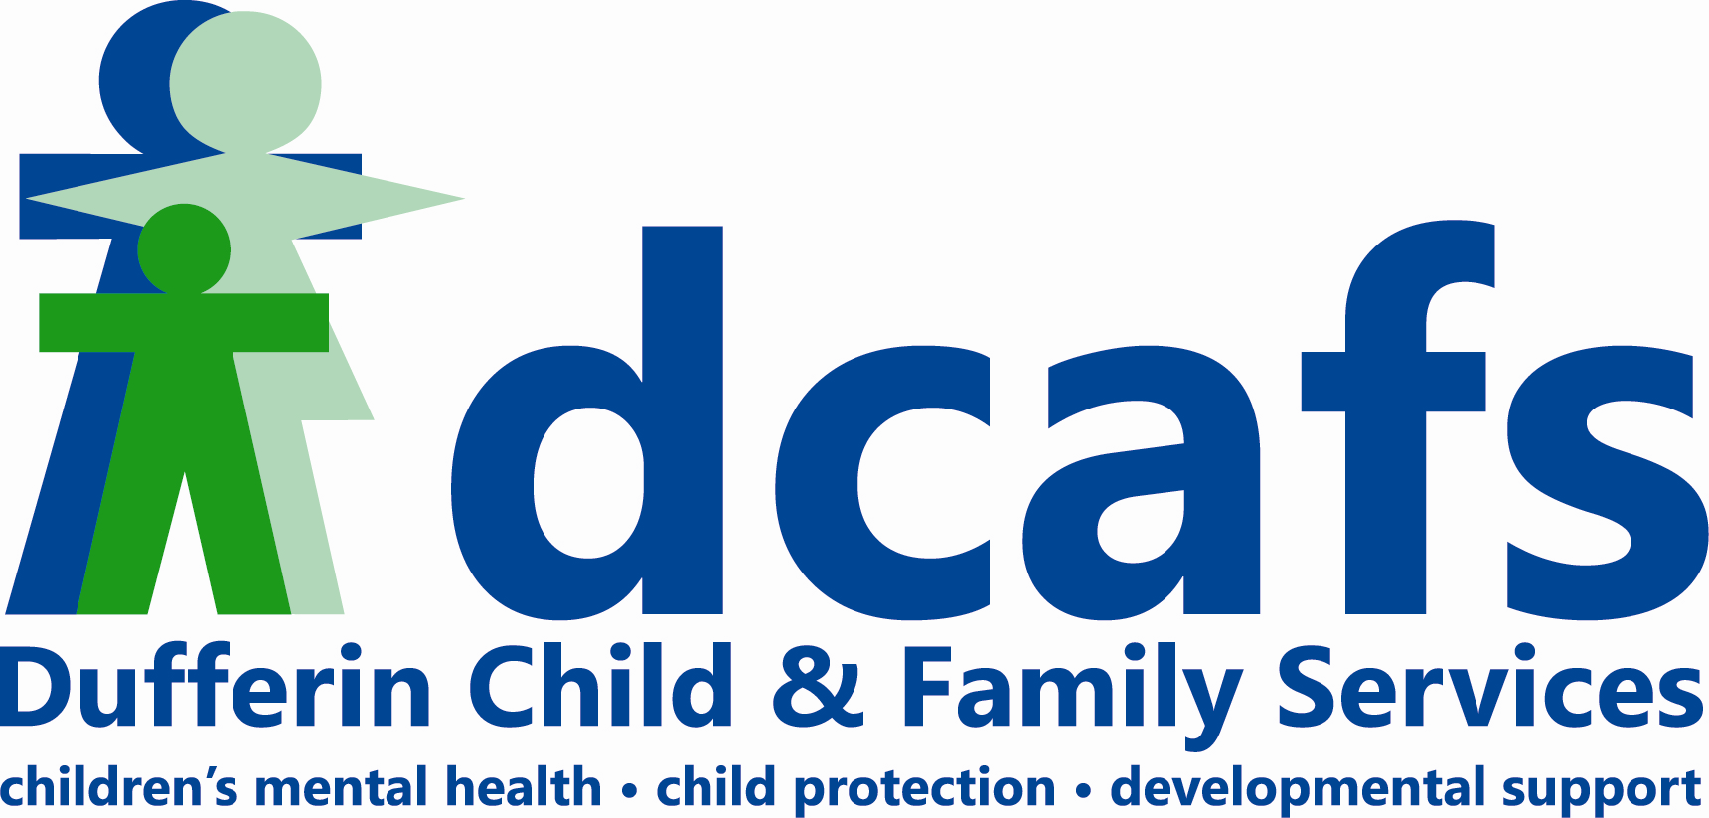

January - June 2011

Provided by:

*Meaghan Jansen*

**Employee Wellness Solutions Network**

[meaghan@EWSNetwork.com](mailto:meaghan@EWSNetwork.com) I 519-860-6727 I [www.EWSNetwork.com](http://www.EWSNetwork.com)

**Table of Contents**

Executive Overview 3

Program Highlights 3-6

Health Coaching

Personal Wellness Profile

Summary and Programming 6

Wellness Program Details Appendix A

Employee Wellness Solutions Network Toolbox Appendix B

**Executive Overview**

The following progression report details the initiatives summary and participation rates during the months of January – June 2011.

The on-site program is designed to address the employees at three different levels – individual, group, and general awareness. Specific details of the wellness program can be seen in the Wellness Program Summary (Appendix A).

**Program Highlights**

Health Coaching (one-on-one wellness consultations)

* For the last 6 months, there has been a 97% booking rate, 75% attendance rate, leaving a 25% cancellation rate with the consultations.
  + - Since January, there have been 139 attended out of 186 booked [out of a possible 192] leaving 47 cancellations. Cancellations vary from workload, sickness or emergencies.
    - Graphs can be seen below demonstrating these numbers.

During this reporting period, there are a few differences noticed compared to last reporting period [June-Dec 2010]:

* Cancellation rates have increased [8% to 25%] but are still lower than the cancellation rates during the reporting period of Jan-June 2010 [29%].
* Higher booking rate than last reporting period [97% vs 89%].

**Personal Wellness Profile (PWP)**

* The Personal Wellness Profile campaign ran in 2009, 2010, and 2011.
* In total, 42% of the population participated in the 2011 campaign.
* Individual reports were available for the participants and corporate summary reports were submitted to management.
* The wellness committee and Employee Wellness Solutions Network designed the wellness program in accordance with the PWP findings and committee feedback.
* A full summary can be viewed in the PWP section of this report.

**PWP Summary**

|  |  |  |  |  |
| --- | --- | --- | --- | --- |
| **Health Risk** | **2009**  **Participation [43%]** | **2010**  **Participation [45%]** | **2011**  **Participation [42%]** | **Change**  **[% from 2009]** |
| Cancer Risk Reduction | 61% | 64% | 58% | 5% decrease |
| Improving Fitness | 74% | 58% | 48% | 35% decrease |
| Better Nutrition | 41% | 36% | 27% | 34% decrease |
| Managing Stress | 33% | 43% | 42% | 27% increase |
| Weight Management | 41% | 33% | 30% | 27% decrease |

The 2011 wellness program efforts were based on the following recommended health actions. Further detail can be seen in Appendix A.

* 1. Improving Fitness
  2. Stress Management
  3. Weight Management
  4. Better Nutrition
  5. Protecting your Heart

**Discussion**

The Personal Wellness Profile is an assessment tool used to determine the areas of focus for wellness program initiatives. It also provides management with an idea of the costs and savings associated with employees with health risks. A few points worth noting:

1. Health Risk Profile – out of the 5 health risks presented in 2009 and again in 2010, most have decreased since 2009 with the exception of Managing Stress which increased 27%.
2. Readiness to Change – The estimated readiness to change distributions in 2009, 2010, and 2011 are different. A summary table is below.

|  |  |  |  |  |
| --- | --- | --- | --- | --- |
| **Readiness to Change** | **2009** | **2010** | **2011** | **Change [%]** |
| Pre-contemplative | 11% | 9% | 0% | 11% decrease |
| Contemplative | 26% | 14% | 15% | 42% decrease |
| Planning Stage | 11% | 6% | 9% | 18% decrease |
| Action Stage | 13% | 14% | 18% | 38% increase |
| Maintenance | 33% | 50% | 58% | 76% increase |

There appears to be a positive shift in deciding to take action and maintaining change since 2009. It can be inferred that 76% of the population is practicing healthy behaviours in 2011 as opposed to 64% in 2010 and 46% in 2009.

1. Preventable Risk Scale – A summary table is below.

|  |  |  |  |  |
| --- | --- | --- | --- | --- |
| **# of Preventable Risks** | **2009** | **2010** | **2011** | **Change [%]** |
| None | 17.4% | 30.6% | 33.3% | 91% increase |
| 1 | 28.3% | 25.0% | 27.3% | 3.5% decrease |
| 2-3 | 26.1% | 22.2% | 24.2% | 7.3% decrease |
| 4-5 | 21.7% | 19.4% | 9.1% | 58% decrease |
| 6+ | 6.5% | 2.8% | 6.1% | 6.1% increase |

The percent distribution of preventable risks shows that there has been a change since 2009. There was a large decrease in the number of participants showing 4-5 health risks [58% decrease since 2009]. Alternatively, there was a slight increase in those participants showing 6+ health risks [6.1% increase since 2009]. Overall, the health risk changes, over three years, are very encouraging and rewarding.

***2011 Wellness Initiative Discussion***

The Personal Wellness Profile is an assessment tool used to determine the areas of focus for wellness program initiatives. It also provides management with an idea of the costs and savings associated with employees with health risks.

The next PWP period is May 2012. A report outlining an Executive Summary, Group Summary, and Economics/Benefits will be presented to management.

Over the last 6 months of wellness programming, many of the health risks were targeted from the last PWP campaign. Specifically initiatives targeting fitness, nutrition, weight management and heart health were presented to staff. The 2011 program will continue to focus on the health risk profile that was completed in May 2011.

A full summary of the wellness programming for the last 6 months is seen in Appendix A.

Healthy lifestyle habits/behaviours will continue to be addressed by expanding the wellness program to include visits from area strategic wellness affiliates at the annual Health Fair [projected for January 2012]. On-site exercise classes will continue, and awareness programs like the healthy recipe circulation, newsletters, team building programs, health education kiosks, themed walk arounds, Smoothie Days, and educational awareness material will also be presented with input from the wellness committee.

It is important to note that all time associated with implementing the group programs and workshops, have to be adjusted from the on-site wellness consultation time/hours.

**Appendix A – Wellness Program Summary January - July 2011**

|  |  |  |  |  |
| --- | --- | --- | --- | --- |
| **Month** | **Date/Duration** | **Initiative** | **Participation** | **Notes** |
| **January** | Weekly | One-on-one consultations | 17 | 14 employees - 1 visit, 1 employees - 3 visits |
| 4th | Wellness Committee meeting |  |  |
| 6th | Interest Survey | 16 | Interest survey conducted to give employees the opportunity to express their preferences for upcoming initiatives. |
| 18th-Feb 8th | Healthy Lifestyle Poker | 8 teams | A 12-workday challenge where participants carry out healthy tasks in order to get cards towards a winning poker hand. Best hand winners: 1st – Michaela Wilvert’s team [4 of a kind], 2nd – Lois Stainton’s team [full house], 3rd – Wendy Mobbs team [flush] |
| **February** | Weekly | One-on-one consultations | 21 | 17 employees - 1 visit, 2 employees - 2 visits |
| All Month | Blood Pressure Kiosk | all staff | Education kiosk set up in staff kitchen. |
| 8th | Healthy Hearts Walk-Around | 80 | Meghan gives out Rooibos tea and informational handout to recognize Healthy Hearts Month. |
| 9th | Wellness Committee meeting |  |  |
| 8th, 15th, 22nd | Health Hearts E-campaign |  | A 4-week e-campaign focusing on how blood pressure, cholesterol, and healthy living ward off heart disease. |
| **March** | Weekly | One-on-one consultations | 30 | 14 employees - 1 visit, 8 employees - 2 visits |
| 1st (8 Tuesdays) | Group Exercise 12:30-1:30pm | 9,7,5,7,5,6,1,2 | An 8-week core and strengthening series with Meghan Davey in the Multipurpose Room. |
| 29th | DCAFS Healthy Snack and Wellness Break | all staff | Healthy snacks available for staff. Sponsored by DCAFS and EWSNetwork. Poker prizes presented to winning team. |
| 29th | Wellness Committee meeting |  |  |
| **April** | Weekly | One-on-one consultations | 22 | 14 employees - 1 visit, 4 employees - 2 visits |
| 6th-May 25th | Wellness Wednesday | all staff | E-mail awareness campaign. Recipes for employees and their families. |
|  | 20th | Eating on the Go 12:30-1:30 | 8 | Eating on the Go lunch n' learn presented by Meaghan Jansen. |
| **May** | Weekly | One-on-one consultations | 27 | 14 employees - 1 visit, 5 employees - 2 visits, 1 employee, 3 visits |
|  | Personal Wellness Profile | 43% participants | Awareness campaign to establish baseline health risk profiles for employees. Group trend reports and corporate analyses are presented to management. |
| 31st | Staff Meeting | all staff | Meaghan Jansen attended to deliver wellness program re-cap and launch of Walking Works. A team-building ice-breaker was delivered as well. |
| **June** | Weekly | One-on-one consultations | 30 | 18 employees - 1 visit, 6 employees - 2 visits |
| 1st-17th | Walking Works |  | Walking challenge to encourage staff to get in as many steps as possible per day. Participant total: 303,000 steps or equivalent to walking to Kingston, Ontario. Draw prize winners: Suzan Fitzgibbons and Sue Douglas. |

**Appendix B – Employee Wellness Solutions Network Toolbox**

**Individual Programming**

* The individual programming conducted by Employee Wellness Solutions Network is the foundation for a successful wellness program. Our unique system provides accountability, follow up and evaluation to positively impact healthy lifestyle habits. Through this custom approach to engaging the employees, behaviours are modified which also affects family health.
* Be it meal planning ideas, recipes, exercise prescription, diabetes information, cholesterol and blood pressure information, quitting smoking, weight loss, stress management, allergies, back health and any other wellness-related topic, our wellness consultants discuss overall lifestyle behaviours with the employees and provide on-going support to gradually see improvements in personal health.
* Confidentiality is of utmost importance for EWSNetwork. Along with our corporate privacy policy, employees are very comfortable in establishing a working relationship with our certified wellness consultants as anything discussed in the consultation is kept confidential and private. EWSNetwork prides itself with this assurance.

**EWSNetwork On-site Wellness Consulting**

Wellness consulting is unique to Employee Wellness Solutions Network.  Participants are encouraged to meet with one of the on-site wellness coaches/consultants to discuss improving or modifying lifestyle behaviors in a closed-door environment. The sessions are 30 minutes in length and are, of course, voluntary.

Topics relating to the individual and improving his/her health is the main focus in these sessions. Topics may range from nutrition, exercise, prevention, disease, stress management, sleep improvement and much more. By working with our wellness consultants, and establishing a trusting relationship, it has been shown that healthy lifestyle behaviours are the result.

“Helping one individual leads to change in his/her family and workplace!”

**EWSNetwork Virtual or Phone Consultations**

For organizations with off-site employees or satellite offices, our wellness consultants can perform individual wellness consultations virtually or over the phone. The same quality of service is evident with these types of consultations. Accountability, follow up and evaluation are paramount with this delivery of service.

**EWSNetwork Personal Wellness Profile [PWP] (Health Risk Assessment)**

The EWSNetwork Personal Wellness Profile is a voluntary, confidential, on-line health assessment tool that measures health risk. Individuals are encouraged to complete this assessment on an annual basis. Wellness scores are determined from the risks and comparative results are presented year to year.

The PWP provides individuals with heightened awareness concerning personal health. From the results of the personal profiles, participants receive a personalized report outlining the main health risks with recommendations for improvement. It is recommended that participants bring their reports to the wellness consultant for review and guidance.

**Group Programming**

* The group programs conducted by Employee Wellness Solutions Network include all lunch n’ learns, workshops, and exercise classes on-site or around the premises. Including this component within a wellness program adds tremendous value. Any group program that leaves the participants with valuable information, contributes to a change in workplace culture. This component has been shown to boost organizational morale and energy.
* Facilitators for the group programs may include the wellness consultants, members of the management team, or our extensive strategic affiliates in the cities we service.

**EWSNetwork Group Exercise Classes**

The EWSNetwork group exercise classes provide participants the opportunity to engage in energy-boosting activity during the workday. Some classes require more space than others, while others are held outside or in boardrooms. Some classes may include: yoga, pilates, kickboxing, tai chi, Get Fit Alliance, Learn to Run, Walk/Run groups to name a few.

 Encouraging activity throughout the day is an important component to improving productivity and energy.

**EWSNetwork On-Site Lunch n’ Learns**

The EWSNetwork lunch n’ learn programs take into account the needs and interests of each organization. EWSNetwork and its strategic network of wellness professionals educate employee groups and organizations on various topics of personal health, worksite dynamics, familial health, financial health, ergonomics, and other wellness topics conducive to the population.

Topics are chosen relating to PWP results, wellness committee feedback, and employee interest. These group sessions encourage a healthy workplace culture, boost morale, may improve overall productivity, and provide a forum for discussion and idea sharing.

**EWSNetwork On-Site Workshops** (4, 6 or 8 weeks)

The EWSNetwork Workshops are unique. They are facilitated over a number of weeks. Each week, a group session is delivered with follow up individual accountability tasks for the next week/session. Some of the workshops include  Work-Life Balance, Extreme Lifestyle Makeover, Easy Nutrition for Life, Healthy Hearts, Waist Watchers, Empowered Living Program, or Healthy Weights to name a few.

 Consecutive group sessions allow for continuity of participants, sharing of ideas, supportive environments, overall morale boosting and culture shifting in the organization.

**EWSNetwork Virtual Lunch n’ Learns and Workshops**

For an organization with employees off-site or in satellite offices, conducting virtual Lunch n’ Learns, wellness sessions, or workshops has proven to be very effective. Interactive webinars, conference video, or conference calls are all options to engage participants who can’t attend these sessions in person.

**EWSNetwork “Step into the Season” Campaign**

The EWSNetwork “Step into the Season” campaigns are walking promotions. Step into Spring, Step into Summer or Step into September offer customized walking routes, pedometer challenges, email campaigns, and accountability tools that help organizations get moving. Group walking groups may also be facilitated during these campaigns.

**EWSNetwork Staff/Wellness Days**

The EWSNetwork staff/wellness day is designed with the needs and interests of the organization in mind. It usually involves speaking with a planning committee to determine what events will be most impactful. A Staff/Wellness Day may incorporate team building, problem solving, empowering relationships, personality learning, human behavior understanding, positive interaction in the workplace, or just FUN! An example of one of the Staff/Wellness Day options is related to the DISC Model presentation.

From the management level to the front line staff, understanding human behaviour and relationships is absolutely imperative for an organization to be successful. The DISC model allows staff to learn how to interact more effectively. This not only is true in the workplace, but understanding clients more effectively is also an objective following this training. *“If I understand you and you understand me, doesn’t it make sense that we can have a better relationship?” Dr. Rohm, Personality Insights*

Some physical and team building programs may include the EWSNetwork Amazing Pace or the EWSNetwork Amazing Hunt lending interaction and fun among staff. The Amazing Pace…and Hunt combines a 5-station team building race that includes physical, emotional and nutritional awareness and a unique Scavenger Hunt. Following the DISC workshop, teams better communicate, strategize, and work together in achieving common goal in the race.

**EWSNetwork Facility Design & Management**

EWSNetwork works with the organization in designing a facility that is conducive to the population. Facility operations and programs within the confines of the workplace are also managed by EWSNetwork. Gym equipment orientations may also be facilitated to ensure safety and personalized programming.

 An on-site exercise facility has shown to support retention and attraction of staff. It also boosts morale, the corporate culture, and overall productivity.

**Awareness Programming**

* The awareness programs conducted by Employee Wellness Solutions Network are critical for a successful wellness program. Touching on the learning styles of individuals, this component to the program lends information in different ways – virtually, kiosk, health fair, bulletin boards, posters, health questionnaires, wellness challenges, awareness campaigns, and newsletters.
* Exposing someone to information pertaining to wellness in one of the above ways might be the first step in assessing one’s health which ultimately leads to further engagement within the wellness program. With the ongoing information, literature and emails supporting health promotion, familial health is also of benefit.

**EWSNetwork Corporate Wellness Profile**

The EWSNetwork Corporate Wellness Profile is presented to management following analysis of the health data from the individuals who complete the Personal Wellness Profile. *The Personal Wellness Profile [PWP] is a confidential, on-line health assessment tool that measures health risk.* From the results of the participants’ profiles, baseline health risks are set and group and aggregate trends are presented. Executive summaries, corporate reports, and economic reports are prepared and submitted to management on an annual basis.

Wellness program design is customized to address the needs and interests of the organization as per the profile results.

**EWSNetwork Awareness Campaigns**

The EWSNetwork Awareness Campaigns promote healthy living in various ways. Some campaigns may include the Personal Wellness Profile, Wellness BINGOs, Cut the Junk baskets, Intranet-based programs, Wellness Warrior, Wellness Wednesday, Pedometer Challenges and Health Fairs as well as many other customized campaigns. Some are incentive-based and others are information-based.

 Awareness campaigns share healthy lifestyle messages, themes, and promotion. Overall learning is enhanced with the innovative and creative ways information is delivered.

**EWSNetwork Awareness Kiosks**

The EWSNetwork Awareness Kiosks are displayed in high-traffic areas at the workplace. The information is presented on a tri-fold and handouts are left to be taken. Some wellness kiosks may include Blood Pressure, Diabetes, Personal Wellness, Sun Safety, Beat the Bug, Smoking Cessation to name a few. Participants are encouraged to take some if the information left at the kiosk home to their families.

Whether it’s reading, gathering some relevant information, or sharing the information with loved ones, participants gather a better sense of overall health and lifestyle.

**EWSNetwork Awareness and Point-of-Decision Posters**

The EWSNetwork Awareness posters are large in size displaying information on a particular topic. These posters range from smoking cessation, to diabetes, to mental health and may correlate with a month’s theme. They share a wealth of information to the reader. Point-of-Decision posters are smaller in size and are often seen in high-traffic areas with an underlying message. Some may include, “Have you taken the stairs lately?” posted in the elevators or “Have you had your 8 glasses of water today?” posted by the water coolers.

Readers gather overall awareness. The underlying messages encourage thinking about positive lifestyle decisions, improvements, or changes.

**EWSNetwork Email/Intranet Campaigns**

The EWSNetwork Email/Intranet Campaigns run over consecutive days or weeks. Emails are circulated (or posted on the intranet) displaying common themes. Some may include 12 Days to Christmas, Step into Summer, Age Defying and Disease Defense, and Beat the Bug to name a few.

**EWSNetwork Newsletter**

The EWSNetwork newsletter is a monthly publication. It offers various articles suitable to the season or current global health topics. Monthly wellness challenges, “Ask the Doctor” and periodic additional bonus articles are also included with this free service. Personal health and familial health may also be affected.

**EWSNetwork Online Resource Centre**

The EWSNetwork Online Resource Centre is free and is open to the public from the main website [www.EWSNetwork.com]. It gives an assortment of various wellness industry articles, archived EWSNetwork newsletters and webinars and also shares a library of wellness information through an additional resource portal.

The Resource Centre is free, allows 24 hours a day access, and is easy to navigate. Not only are employees using this extensive library, families are too.