7083 Life Wheel

A simple test to help you discover how out of balance your life is at the moment, and those areas where you need to invest more time if you want to avoid problems of over working, stress and work related ill health.

Are you balanced?
Using the chart below, please rate each area of your life between 1 and 10 (10 being excellent and 0 being poor). Then plot your answers on the above “Wheel of Life”. Plot the numbers closer to 10 near the edge of the wheel and the lower numbers closer to the intersection / middle of the wheel (0 = intersection, 5 = middle, 10 = edge of circle). Connect the lines. A “wheel” works the best if it is circular and balanced. How circular is your wheel? How balanced are you right now?

Health |  | Relationships
Wealth |  | Work/Career
Family/Friends |  | Personal Time/Space
Playtime, Hobbies, Fun |  | Contribution/Spirituality

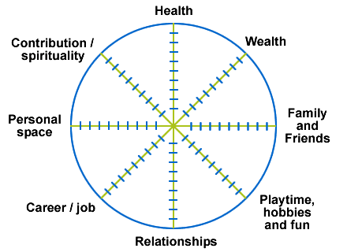

Source: www.worklifebalancecentre.org

Personal Wheel of Life DATE ________

Make your own wheel of life with other important facets of your life.

Step 1: Use some of the following examples or create a list of areas that make up your life. Examples: mental health, physical health, leisure time, relaxation, family, husband/wife/partner, spirituality, self-development, career development, home/lifestyle, travel, study, voluntary work, community, friends/socializing.

Step 2: Write each facet of your life in the table below along with rating the areas 1-10 [1 is unhappy and 10 is very happy and satisfied].

Step 3: Once you have decided on your rating, count the markers on that spoke from the middle towards the outer rim of the wheel. Do this for each area. When you have all 8 spokes marked you will have a picture of the balance in your life. How circular is your wheel? How balanced are you right now?

