

Staying Healthy

with diabetes

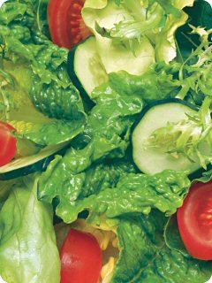
If you have diabetes, taking
care of yourself will help you
prevent complications.

- Keep blood glucose levels in target range

- Keep your blood pressure and cholesterol in check

- Maintain a healthy weight
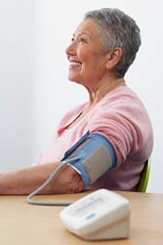
- Follow a balanced meal plan

- Be physically active

- Don’t smoke

- Manage your stress effectively

Visit your diabetes healthcare team regularly.

Canadian Diabetes Association

Healthy Eating

for diabetes prevention
and management



- Eat three meals a day at regular times

- Limit your sugars and sweets

- Limit high fat foods

- Eat more high fibre foods

- Drink water more often
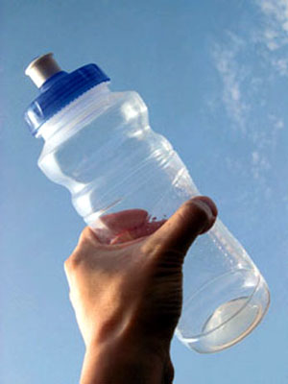
- Follow Canada’s Food Guide to Healthy Eating


Canadian Diabetes Association

Active Living

for diabetes prevention
and management

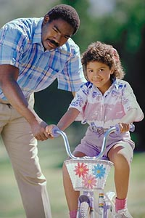
- Make time for physical activity every day

- Move more and sit less

- Try new activities with family and friends

- Aim for 60 minutes of daily activity in 10 minute blocks

- Start slowly and increase effort gradually


- Follow Canada’s Physical Activity Guide to Healthy Active Living

- Physical activity is a great stress buster

Canadian Diabetes Association

Signs
and Symptoms
of diabetes include


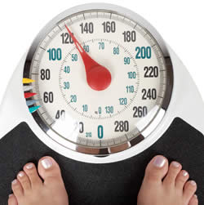
- Unusual thirst

- Frequent urination

- Weight change

- Extreme fatigue

- Blurred vision

- Cuts and bruises that are slow to heal
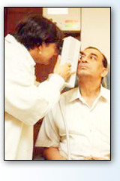
- Tingling and numbness in the hands and feet

It is possible to have no obvious symptoms, and still have type 2 diabetes.

Canadian Diabetes Association

One in 13 Canadians

has diabetes


Type 1 diabetes

- No insulin produced

- About 10% of people with diabetes

- Usually diagnosed in children and young adults

Type 2 diabetes

- Not enough insulin produced or body cannot use insulin properly

- About 90% of people with diabetes


- Most often diagnosed in adults

Gestational diabetes

- Affects 2 to 4% of all pregnancies

- Increased risk of developing type 2
diabetes later in life

Canadian Diabetes Association

Are You at Risk

for type 2 diabetes?

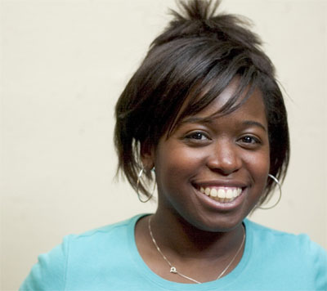


Are you:
- 40 or over?

- Overweight?

- Of aboriginal, Hispanic, South Asian or African descent?

Do you have:
- A parent, brother or sister with diabetes?


- High blood pressure or high cholesterol?

Have you:
- had a baby over 4 kg (9 lb) or had gestational diabetes?

If you answered yes to any of these questions, talk to your doctor.

Canadian Diabetes Association

The Seriousness
of diabetes

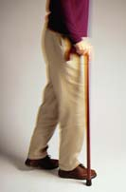
Whether you have type 1 or type 2 diabetes, you may be at risk of developing complications such as:

- Heart disease and stroke

- Eye disease and adult blindness

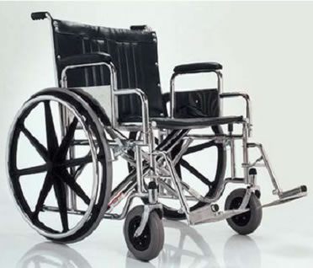
- Kidney disease

- Foot ulcers

- Amputation

- Erectile dysfunction

You can delay or prevent these complications by taking care of yourself and managing your diabetes.

Canadian Diabetes Association
For further information on bettering your lifestyle, please feel free to contact your Employee Wellness Solutions Network wellness consultant. You can also view many more related articles at EWSNetwork.com under the EWSNetwork Resource Centre. Please feel free to e-mail us at info@EWSNetwork.com with any questions, comments, and/or feedback.

We all want the “QUICK-FIX” when it comes to bettering our health. A proper nutritional diet (that’s full of variety and balance) AND some physical activity, WILL make all the difference.

Take the Diabetes Risk Assessment

Enter your name to WIN!

If you have any questions about it or anything else, please contact your Employee Wellness Solutions Network wellness consultant or e-mail us info@EWSNetwork.com.

WIN a Diabetes Management /
Prevention Guide with COOKBOOK!

Each time you visit the Diabetes Kiosk (for material or to take the Risk Assessment) enter your name to WIN!

The more times you visit, the more times you can enter your name.

Important Nutritional Information

Please help yourself to any of the material presented.

Whether you’ve been diagnosed with Diabetes or not, we should ALL eat the way Diabetics are encouraged to eat.

GOAL – To maintain blood glucose control through DIET and EXERCISE.

A few key points to ponder when you eat your next meal:
- Are you eating a PROTEIN and a CARBOHYDRATE source together?
- Are the carbohydrates you’re choosing to eat LOW GLYCEMIC?
- Are you limiting sugars and sweets (pop, desserts, candies, jam, honey)?
- Are you limiting the amount of high fat foods you eat (pastries, chips, fried food)?
- Are you eating high fibre foods?
- Are you drinking the required 8 glasses of water a day?

