**Sun Safety Tips!**

You can still enjoy your time outdoors, but it is important to take a few simple precautions. To prevent damage from the sun:



* Wear clothes that cover your skin.
* Wear a broad-brimmed hat.



* Wear sunscreen on skin that is not covered (SPF of at least 15).

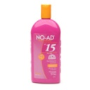

* Look for Environment Canada’s UV Index in your everyday forecast: you can hear it on the radio, on TV, in the newspaper or on the internet.



* Wear sunglasses that provide UVA and UVB protection.
* Try to spend less time in the sun. Seek shade between 11am and 4 pm.

