**Safety in the Sun**

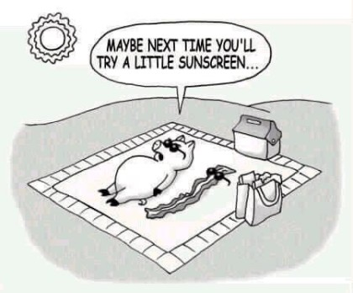

Energy from the sun sustains all life on earth. However, some forms of the sun’s energy can be harmful to us. This includes the sun’s ultraviolet (UV) rays. The earth’s ozone layer – a thin veil of gas high in the earth’s atmosphere – acts as our planet’s sunscreen. In the past few years, the ozone layer has become thinner because of the effects of pollution and chemicals. Now, more of the sun’s UV rays can reach the earth’s surface, which is why we need to be extra careful when we are exposed to the sun!