Presenting the
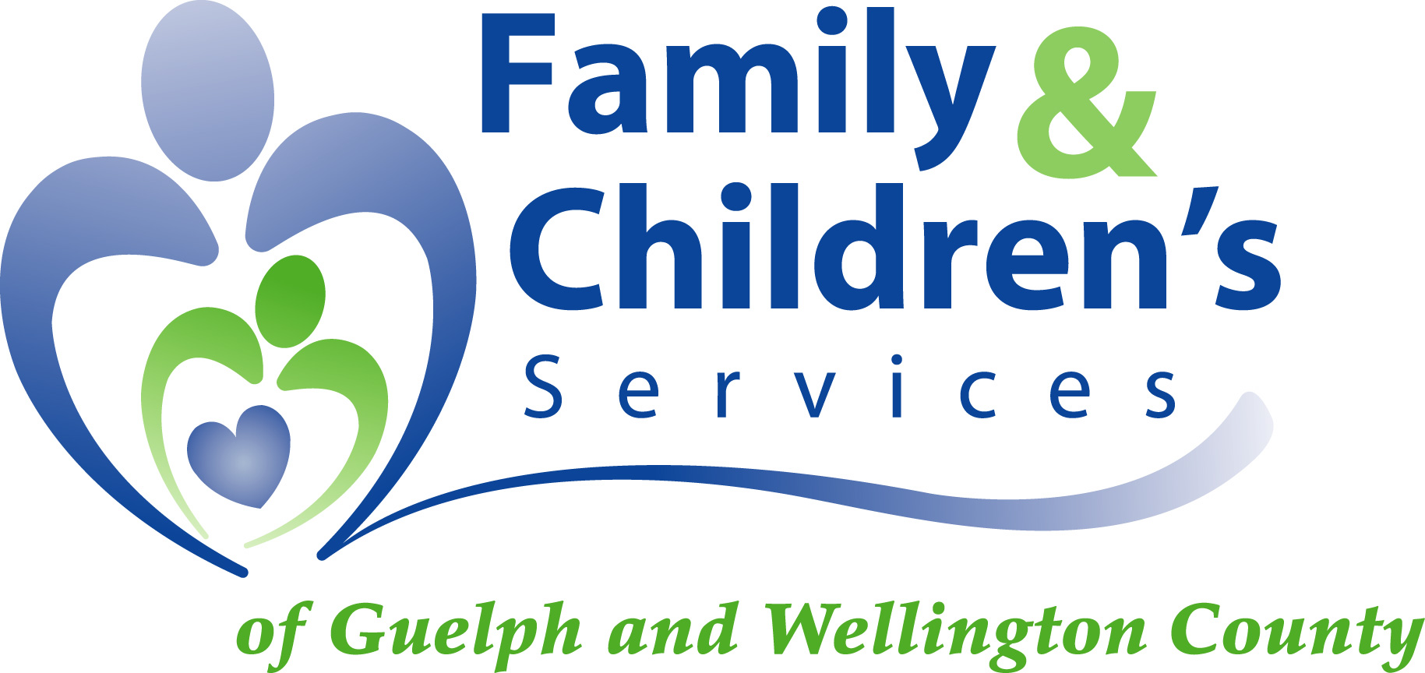

Health & Wellness Program

Coming in November
FCSGW is launching its NEW
Employee Health & Wellness Program.

Supported by your management team, this program is designed to assist you in enhancing your overall lifestyle.

November Events

Wednesday, Nov. 17th – Staff Information Sessions and Program Launch
You are invited to attend the FCSGW Wellness Program Launch on Wednesday, November 17th. Meaghan Jansen along with Meghan Davey and Michelle Paczay, wellness consultants, will be sharing the on-site wellness program details. Take this opportunity to meet the Employee Wellness Solutions Network team and get signed up for programs.

Wednesday, Nov. 17th – Wellness Committee
Hear about how you can become involved in the design of your wellness program by participating in the wellness committee. More details at the launch.

Starting week of Nov. 22nd - One-on-One Wellness Consultations
This is your opportunity to work with a wellness coach. Get information pertaining to nutrition, exercise, sleep improvement, stress management, and so much more right here on-site! You can discuss any of your personal wellness goals with our certified wellness specialists, Meghan and Michelle. Details will be shared on November 17th.


Services Provided by:

www.employersedge.ca
