Presenting the
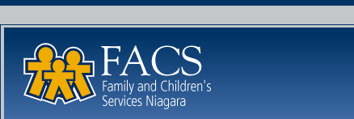


Health & Wellness Program

Coming in October, FACS Niagara is launching its new Employee Health & Wellness Program.

Supported by your management team, this program is designed to assist you in enhancing your overall lifestyle.

October Events

Tuesday, Oct. 5th – Staff Information Sessions and Program Launches
You are invited to attend the FACS Niagara Wellness Program Launch on Tuesday, October 5th. Meaghan Jansen, owner of Employer’s Edge, and Tamara Brouwer and Colleen Willick, wellness consultants, will be sharing the on-site wellness program details. Take this opportunity to meet the Employer’s Edge team and get signed up for programs.
SCHEDULE:
St. Catherines office sessions 9-10am and 10-11am
Niagara Falls office session 1:30-2:30pm
Welland office session 3-4pm

Tuesday, Oct. 5th – Wellness Committee
Hear about how you can become involved in the design of your wellness program by participating in the wellness committee. More details at the launch.

Starting week of Oct. 12th - One-on-One Wellness Consultations
This is your opportunity to work with a wellness coach. Get information pertaining to nutrition, exercise, sleep improvement, stress management, and so much more right here on-site! You can discuss any of your personal wellness goals with our certified wellness specialists, Tamara and Colleen. Details will be shared on Oct. 5th.

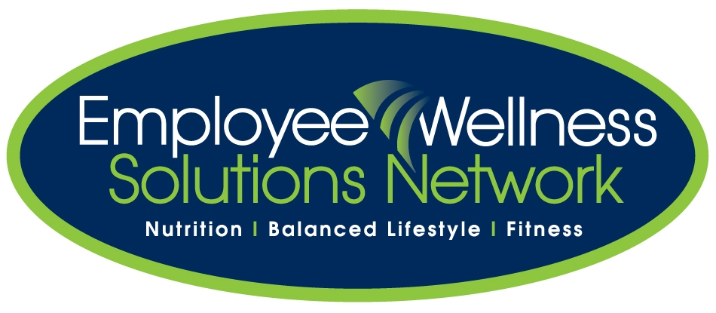
Services Provided by:

www.EWSNetwork.com

