If you are here for your Wellness Consultation, please knock so I know you have arrived. Thanks,
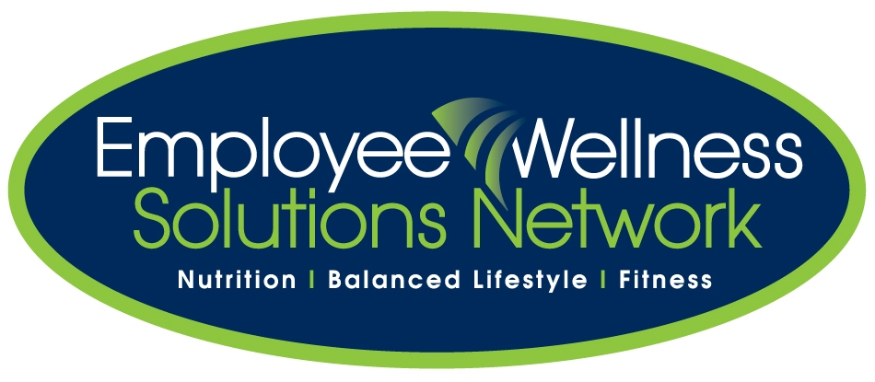

Consultant:
Tamara Brouwer tbrouwer@EWSNetwork.com

