What’s Out There?

Nicotine Replacement Therapy
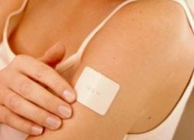
These medical assistants contain nicotine but in smaller (and decreasing) doses than what you would be normally consuming while you smoke. These are aimed to decrease/stop the cravings and make it easier to deal with the natural withdrawal symptoms.

Five common therapies:
1) Nicotine nasal spray
2) Nicotine patches
3) Nicotine inhalers
4) Nicotine gums
5) Nicotine lozenges

While the nicotine patches, gums and lozenges are easily available as 'over the counter' products, the nicotine nasal sprays and inhalers can be purchased only with a physician's prescription.

Laser and Acupuncture
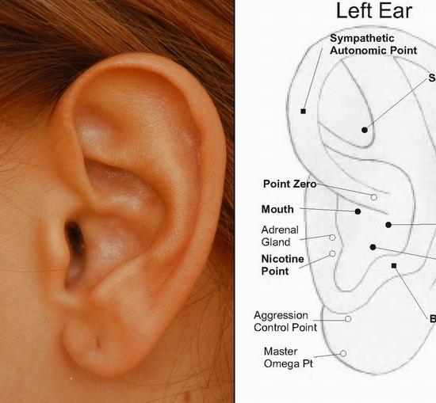

Laser treatment for quitting smoking is a relatively new method but has proven to be effective. It works on the same method as acupunture by taping into various points on the body that are nerve centers that encourage bodily changes.

Low intensity laser beams are applied to different parts of the body – the result - reduction in cravings for cigarettes.
Herbals
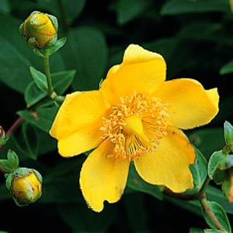
One natural substance that is used to quit smoking is lobelia. This is an old and controversial herb. It acts as a relaxant. It reduces inflammations and pain. It checks hyperactivity. It eases muscle tension and convulsions. This eases mild depression. However this product must be used with caution as you are still inhaling smoke. St. John’s wart has also shown to be helpful with quitting smoking. It increases the dopamine levels that will feel as though they have dropped as nicotine is no longer giving that “aaahhh” effect from mimicking acetylcholine.
Check with your doctor prior to any therapies!

Cold Turkey
This is obviously the completely cost-free way to quit smoking. But beware! Stopping cold turkey will take more than will power. It takes planning, preparation and knowledge.

Withdrawal symptoms:
- Headaches, nervousness and irritability
- Trouble sleeping
- Constipation
- Coughs
- Dizziness
- Changes in appetite

Source: Canadian Cancer Society “For smokers who want to quit: one step at a time”

