9058 - Readjusting to Being Smoke Free
Being smoke-free won’t feel natural at first. Just as it took you weeks, months, years to develop the habit it will take time for your body to re-adjust to quitting. Be patient with yourself. Remember that the benefits of being smoke-free outweigh the feelings cigarettes once brought you. Here are several things to keep in mind on your journey to a smoke-free life.

Your smoke free timeline:
8 hours after you quit smoking there is already more oxygen to your system and your blood pressure is decreasing. It feels as though you have taken 200 lbs off your body’s systems.
After 1 day your lungs are working better and you have more breath.
After 2 days your sense of taste and smell are getting stronger. You will be coughing lots this day as your body is clearing mucus from your lungs.
After several days blood flow improves and you won’t feel as cold.
After 1 year your chance of getting a heart attack has halved! Congratulations!

Ways to keep on track!
Renew your reasons: Before you quit smoking you had a reason, or many, for doing it. Now that you have quit, renew those reasons. Re-commit to yourself why you have decided to take on this healthy and empowering new life change. Write them down, stick them up, make them easy for you to see and push you on.

Control your Environment:
The hard part is done. You’ve quit and you’re committed. But you still need to work hard to stay focused and stay away from temptation. You can accomplish this by controlling your environment. Control where you are on your breaks. Control who you hang around with for the next few weeks. Control where you go after work. Control your morning routine. Control if you have cigarettes, lighters and matches in the house. It’s up to you to stay committed and stay in control!

Reducing stress!
Relaxing Breathing
- Lie down or sit on the floor or in a chair
- Rest your hands on your stomach
- Slowly count to four as you inhale through your nose. Feel your stomach rise – hold this for a second.
- Slowly count to four while you exhale through your mouth. To control how fast you exhale, purse your lips like you’re going to whistle. Your stomach will slowly fall.
- Do this a few times.

Gentle Stretching
- Lift your shoulders to yours ears, then drop them down again and relax for 10 seconds. Do this three to four times.
- Slowly turn your head to the right. Hold for 10 seconds. Repeat on left.
- Drop your chin to your chest – relax for 10 seconds.
- Reach above your head with your right arm. Bring it down. Repeat with left.
- Lean to the right as far as you can from the waist. Repeat with left side.
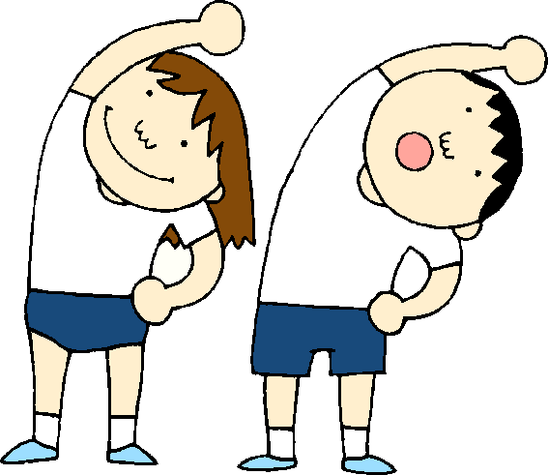
- Straighten your right leg, lifting your foot off the floor – hold for 10 seconds. Repeat with the left. Do this three to four times.

Source: Canadian Cancer Society’s “For smokers who want to quit smoking; one step at a time”

