**9060 - What’s Out There To Help You Quit?**

**Nicotine Replacement Therapies**

These medical assistants are available in various forms. They all contain nicotine but in smaller (and decreasing) doses than what you would be normally consuming while you smoke. These are aimed to decrease/stop the cravings and make it easier to deal with the natural withdrawal symptoms.

Here are five common types of nicotine replacement therapies:

1) Nicotine nasal spray

2) Nicotine patches

3) Nicotine inhalers

4) Nicotine gums

5) Nicotine lozenges

All these nicotine replacement products are approved by the US Food and Drug Administration (FDA). While the nicotine patches, gums and lozenges are easily available as 'over the counter' products, the nicotine nasal sprays and inhalers can be purchased only with a physician's prescription. All of these methods are best coupled with behavioural therapy. Have someone help you deal with the psychological and mental dependences!

**Laser**

Laser treatment for quitting smoking is a relatively new method but has proven to be effective. It works on the same method as acupuncture by taping into various points on the body that are nerve centers that encourage bodily changes. Low intensity laser beams are applied to different parts of the body – the result - reduction in cravings for cigarettes.

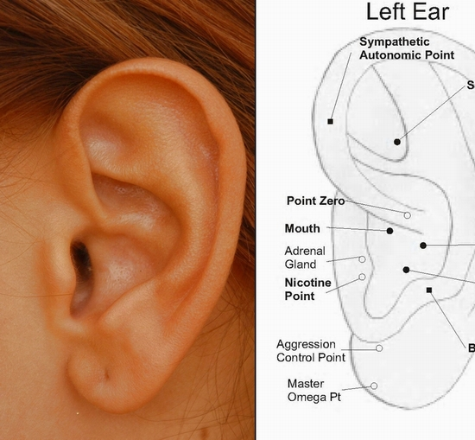

**Acupuncture**

Acupuncture uses small needles of different lengths and sizes to stimulate the skin in a particular area of the human body. The area for stimulation is chosen corresponding to meridians or pathways that provide energy to the affected body field or area. When acupuncture is used for quitting smoking, the needles are inserted to the areas that will affect energy flow to the [mouth](http://www.stop-smoking-updates.com/quitsmoking/), lungs and respiratory system as well as to the parts of the brain that create cravings for tobacco smoke.

**Herbals**

One natural substance that is used to quit smoking is lobelia. This is also called as Indian tobacco. This is an old and controversial herb. It acts as a relaxant, reduces [inflammations](http://www.stop-smoking-updates.com/quitsmoking/) and pain, checks hyperactivity, and eases muscle tension and convulsions. Many say that this herbal product makes the taste of regular tobacco, repulsive. Naturalists say that it calms the nerves and relaxes body muscles. This eases mild depression. However this product must be used with caution as you are still inhaling smoke. St.John’s wart has also shown to be helpful with quitting smoking. It increases the dopamine levels that will feel as though they have dropped as nicotine is no longer giving that “aaahhh” effect from mimicking acetylcholine. *Source:* www.stop-smoking-updates.com

**Cold Turkey**

This is obviously the completely cost-free way to quit smoking. But beware! Stopping cold turkey will take more than will power. It takes planning, preparation and knowledge. Withdrawal symptoms that you will most likely experience no matter the method chosen are:

* Headaches, nervousness and irritability, trouble sleeping, constipation, coughs, dizziness, changes in appetite

Being aware of what’s to come makes it easier for you to accept things as they pass.

*Source*: Canadian Cancer Society “For smokers who want to quit: one step at a time”