What is Seasonal Affective Disorder (SAD)
SAD is a mild to moderate form of depression that comes on as the summer changes into the fall and winter seasons. SAD is a cyclical depression where the feelings of “winter blues” come back each winter season.

Symptoms

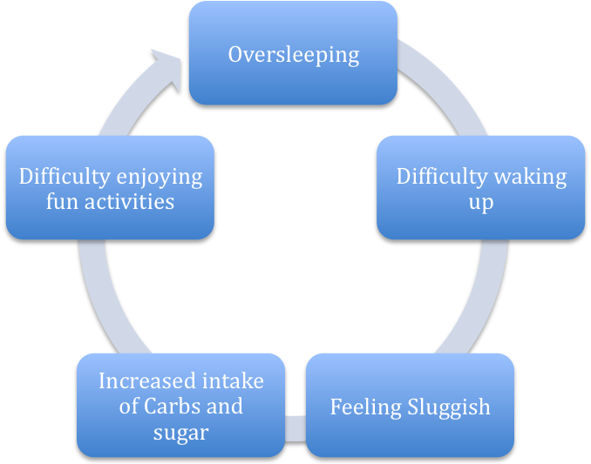

Source: Giorgio Piccoli, 2007. Beating the Winter Blues: A practical guide on how to get through the winter at Cornell

