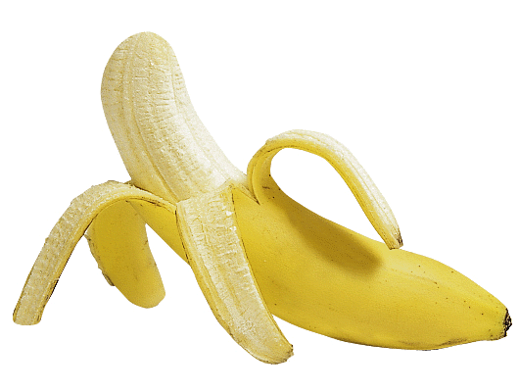
Banana - Berry Wake-Up Shake

Makes about 31/4 cups (800mL) - Serves - 2
1 banana
1cup fresh or frozen berries (any combination)
1cup milk or vanilla-flavoured soy beverage
3/4cup lower-fat yogurt (vanilla or other flavour that complements berries)
In a blender liquefy fruit with a small amount of the milk. Add remaining milk and yogurt; blend until smooth. If shake is too thick, add extra milk or soy beverage to achieve desired consistency.
MAKE AHEAD - Make these shakes the night before and you'll be ready for a quick morning meal to go.
TIP - This protein rich shake will help to maintain blood sugar levels and counteract cravings for sweets.
TIP - The vanilla yogurt used in these shake recipes is higher in carbohydrate than most other yogurts. People with diabetes may want to choose a lower carbohydrate brand.
TIP - Frozen sliced bananas work well in these shakes and help make them creamy. When bananas start to get brown, pop them in the freezer and take out as needed.
This protein rich shake will help to maintain blood sugar levels and counteract cravings for sweets.
PER SERVING
Calories | 234 | Carbohydrate | 43.8
Protein | 8.7g | Dietary Fiber | 3.2g
Fat25 | 3.8g | Sodium | 114mg
Excellent source of calcium, riboflavin vitamin B6 & B12. Good source of vitamin C and folacin.

This recipe has been provided by the Dietitians of Canada - "Great Food Fast" - published by Robert Rose Inc.
Listings of London Dealers for SAD light boxes.
1-800-387-0896 www.day-lights.com
- Any Shoppers Home Health Care
- Yurek Home Health Care. 371 Wellington Rd S PH: 519-963-1142
- Motion Specialties London 193 Adelaide St. S PH: 519-685-0400
- CDS Pharmacy 1695 B Wonderland Rd. N PH: 519-472-2345
- Coulter’s Pharmacy 1709 Dundas St. PH: 519-451-0750
- McNiece Tens Inc. 954 Leathorne St. Unit 8 PH: 519-681-8367

