Treating SAD with Sleep, Light, and Medication

Regulating Sleep
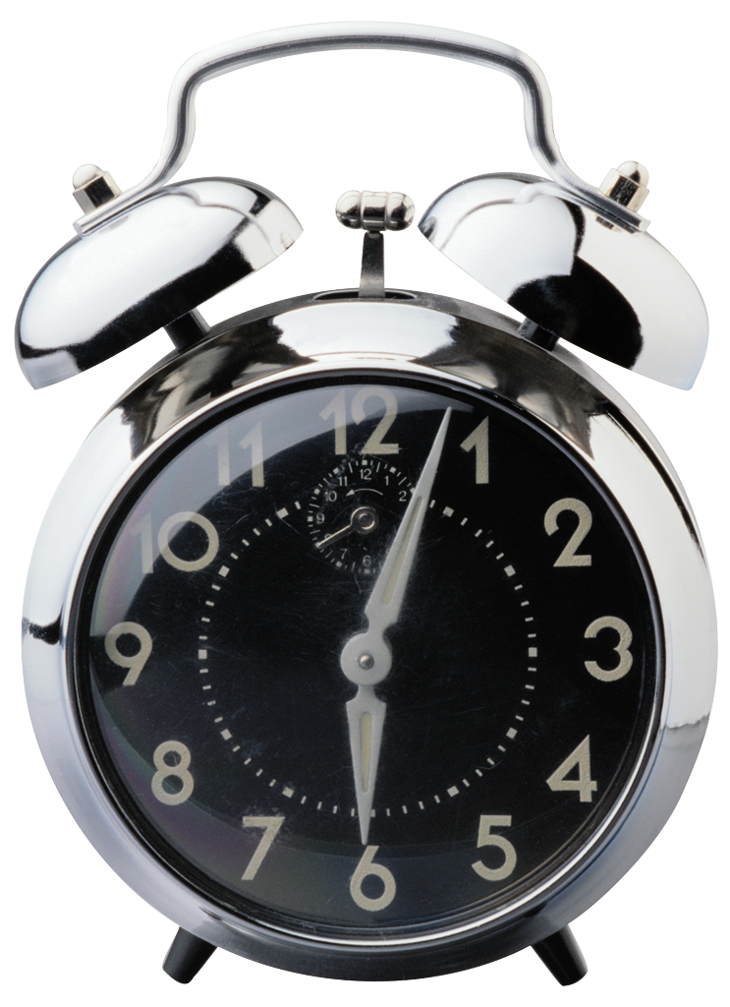
In order to get the most sunshine out of your day it’s important to make the effort to be up during the sunlight hours. Going to bed late and sleeping in will contribute to the lack of sunshine you’ll receive. Setting a regular sleep schedule is also important so you don’t oversleep. According to Gannet Health Services, “Oversleeping and fluctuations in sleep-wake schedule causes increase in levels of melatonin during sleep, which can contribute to feelings of depression.” Aiming for an eight hour sleep schedule is great!

How Light Can Help
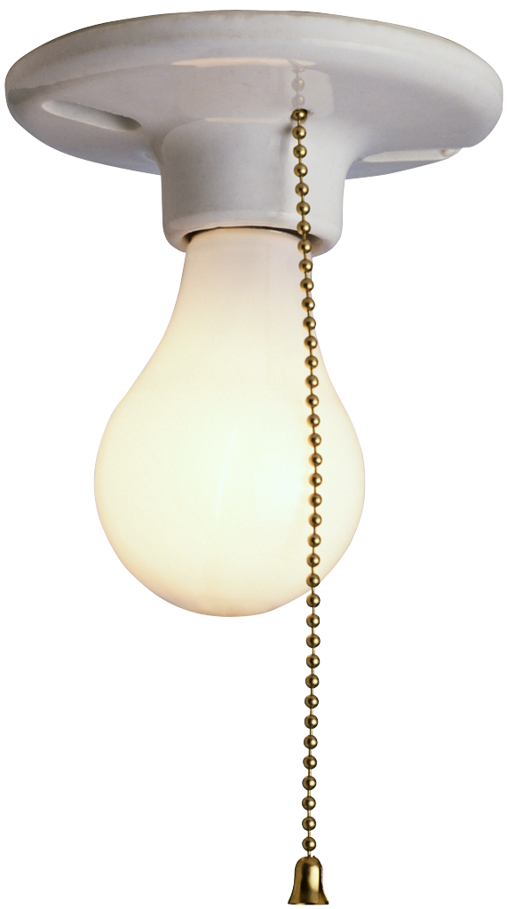
Light boxes are commonly used to treat SAD. A light box is a small rectangular box that contains light bulbs with intensities between 2 500 and 10 000 lux (compared to the regular 250 to 500 lux in an ordinary light bulb.) This high intensity light mimics the sun’s natural rays and will contribute to combating the low levels of light received in the winter months. Using the light box daily for any time between 30 minutes and 2 hours will help. Other helpful hints are keeping all blinds open during the day to allow as much sunshine in as possible. When waking up in the morning opening your blinds and letting the light in will help you wake up. (Rebecca Armstrong, The Independent, 2007)

Medication

As with any type of depression the option for medical treatment is always available. After consulting with your doctor the option of SSRI’s (Selective Serotonin Re-uptake Inhibitors) may be a viable option. These are anti-depressants and can be discussed further with your health care professional. An alternative to SSRI’s is St.John’s Wort, an effective natural antidepressant. Also the use of supplements such as cod liver oil to increase your vitamin D may be helpful. Our bodies naturally produce vitamin D through our exposure to sunlight. As this decreases during the winter months its important to replenish your vitamin D reserves.
source: Rebecca Armstrong. The Independent. “How to beat the Winter blues” 2007

MOST IMPORTANTLY GET OUTSIDE!
While our time in the winter sunshine may be limited its important to make every effort to get outside whenever possible. If you are stuck in an office during the sunny hours try and sit by a window and look outside. Every bit of sunshine helps fight off the symptoms of SAD.

