November 8:

Task 1 – Eat 1 medium fruit

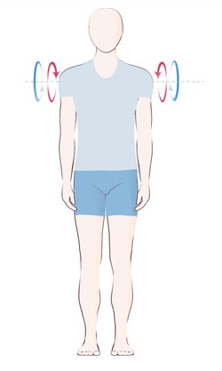
Task 2 – Deskercise – Do 10 shoulder roles [both ways]

November 9:

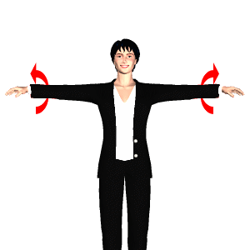
Task 1 – Deskercize – Do 15 arm circles (both arms)

Task 2 – Eat some protein today (ie: fish, chicken, eggs, beans, dairy, nuts)
November 10:

Task 1 – Eat ½ cup GREEN vegetables (salad, peas, broccoli, etc…)

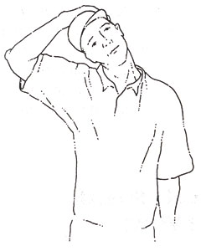
Task 2 – Deskercise – Do a neck
stretch
for 20 seconds
(both sides)
November 11:

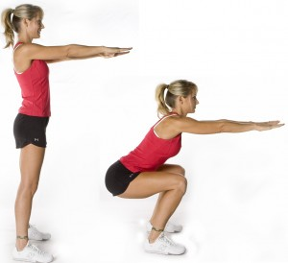
Task 1 – Deskercize – Do 10 squats

Task 2 – Eat breakfast today

November 12:

Task 1 – Drink 8 glasses of water today

Task 2 – Eat some protein today (ie: fish, chicken, eggs, beans, dairy, nuts)

November 15:

Task 1 – Eat a snack today

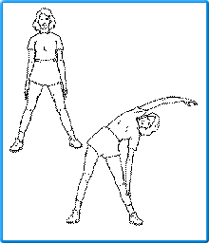
Task 2 – Deskercize – Do a torso stretch for 20 seconds (both sides)

November 16:

Task 1 – Eat ½ cup GREEN vegetables (salad, peas, broccoli, etc…)

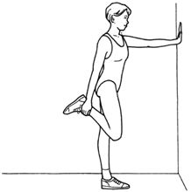
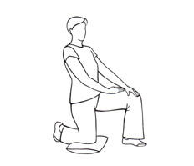
Task 2 – Deskercize – Do a quad stretch (hold each si de 20 seconds)

OR
November 17:

Task 1 – Eat 1 medium fruit

Task 2 – Deskercise – Do 10 shoulder roles [both ways]

November 18:

Task 1 – Eat a snack today

Task 2 – Deskercize – Do a quad stretch (hold each si de 20 seconds)
OR

November 19:

Task 1 – Drink 8 glasses of water today

Task 2 – Deskercize – Do a torso stretch for 20 seconds (both sides)

November 22:

Task 1 – Deskercize – Do 10 wrist roles (both ways)

Task 2 – Deskercize – Do a quad stretch (hold each si de 20 seconds)
OR

November 23:

Task 1 – Deskercize – Do 10 squats

Task 2 – Deskercise – Do a neck
stretch
for 20 seconds
(both sides)

