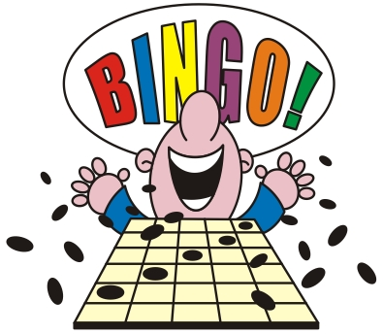
Captain Log Sheet
Healthy Task Log | Nov 8 | Nov 9 | Nov 10 | Nov 11 | Nov 12 | Nov 15 | Nov 16 | Nov 17 | Nov 18 | Nov 19 | Nov 22 | Nov 23

*when all participating teammates complete the daily tasks, put sticker on your card corresponding to the task.

