Stress Workshop – Week #3
Metabolism
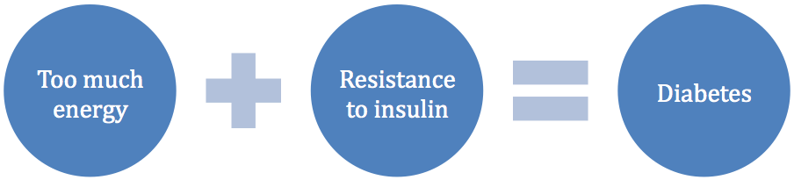
When we are stressed, our bodies secrete the stress hormone _________________________ which increases our appetite and stimulates glucose production for energy, which in turn stimulates insulin which in turn stores the excess glucose as fat. This back and forth insulin production leads to weight gain. This cycle can also be a precursor for diabetes.

Exercise Can Help:
- Cardiovascular benefits
- Protects against brain aging and cognitive decline
- Cerebral vasculature functions more highly
- Stimulates new neurons in the brain
- Makes new nerve growth factors that helps to make new connections and new processes within the brain
Ask Yourself…
- What do you like to do?
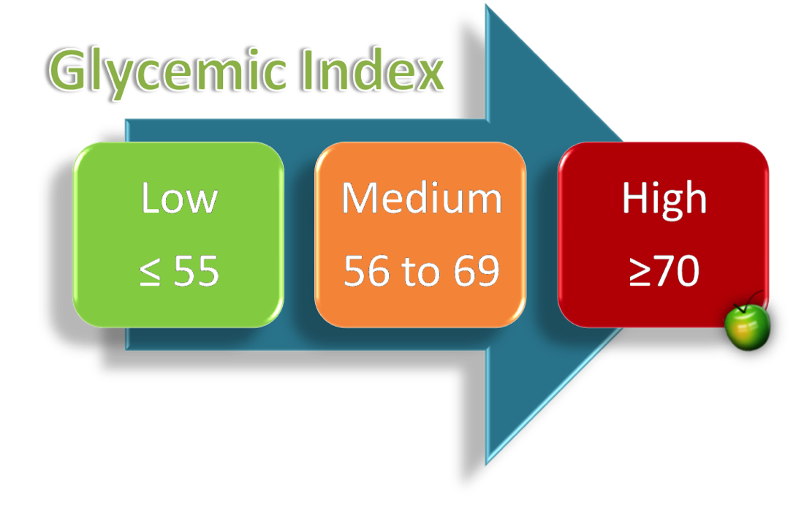
- Do you like to be alone or with friends?
- What time of day works best for you?
- What can you reasonably fit into your schedule?
- Are you willing to make yourself a priority?
Stress and Nutrition:
Eat foods that are low on the glycemic index: vegetables, lean proteins, legumes.
Why?
Low GI = weight management, weight loss, improved sensitivity to insulin, improved diabetes control, regulates blood sugar, satiety effect (feeling full), prolonged physical endurance

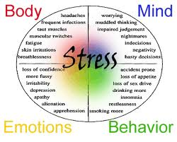

Notes:
__________________________________________________________________________________________________________________________________________________________________________________________________
__________________________________________________________________________________________________________________________________________________________________________________________________
__________________________________________________________________________________________________________________________________________________________________________________________________
__________________________________________________________________________________________________________________________________________________________________________________________________
__________________________________________________________________________________________________________________________________________________________________________________________________

