Stress Workshop – Week #2
Sleep Is… Regeneration and rest for the brain. Your brain actually uses 20-25% of you body’s energy.
Why Sleep?
- To Regenerate energy for the brain
- To Consolidates memories
- Some brain circuits become more active than in waking hours
- Glucocorticoids are low during sleep
Two Types of Sleep:
- REM (Rapid Eye Movement): When dreaming and memory consolidation take place. Insufficient REM sleep can lead to decreased cognitive function (mood, memory, decision making…)
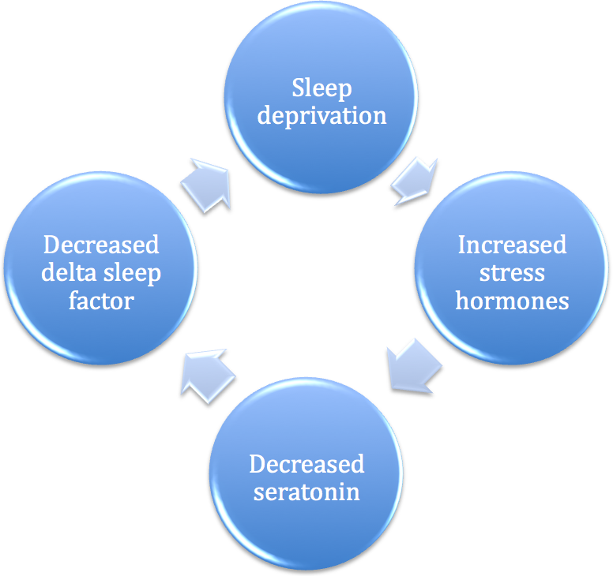
- Low-Wave Sleep: When energy restoration/rejuvenation takes place (most easily interrupted by stress).
Not Enough Sleep?

One dose of caffeine = 250ml

Create Your Own Personal Prescription for Sound Sleep:
Bedroom: _____________________________________________________________________________________________
Bed: ___________________________________________________________________________________________________
Bedtime: _____________________________________________________________________________________________
Food/Bedtime Snacks: ____________________________________________________________________________

Strategies for Clearing Your Mind:
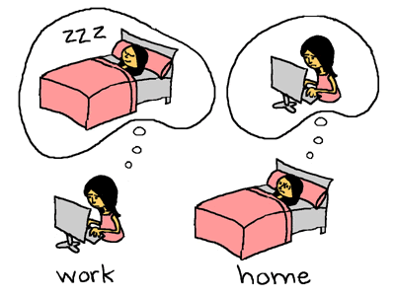
- Have things ready for the morning
- Keep pad and pencil beside the bed
- Worry tomorrow!
- “I am so looking forward to a good sleep tonight.”
- Quit smoking

Meditation:
- Give full focus to the present
- Watch your breath as you inhale and exhale
- Allow thoughts to cross your mind without judgment and without emotion
- Daily meditation of 3-5mins is more beneficial than weekly for 30mins

Cognitive Distortions that Lead to Anxiety and Worry:
All-Or-Nothing Thinking: __________________________________________________________________________
The Mental Filter: ___________________________________________________________________________________
Overgeneralization: ________________________________________________________________________________
Notes:
__________________________________________________________________________________________________________________________________________________________________________________________________
__________________________________________________________________________________________________________________________________________________________________________________________________
__________________________________________________________________________________________________________________________________________________________________________________________________
__________________________________________________________________________________________________________________________________________________________________________________________________
__________________________________________________________________________________________________________________________________________________________________________________________________

