
Healthy Lifestyle Poker

Complete Healthy Tasks,
Earn Cards, and Help your team WIN a Poker Hand!


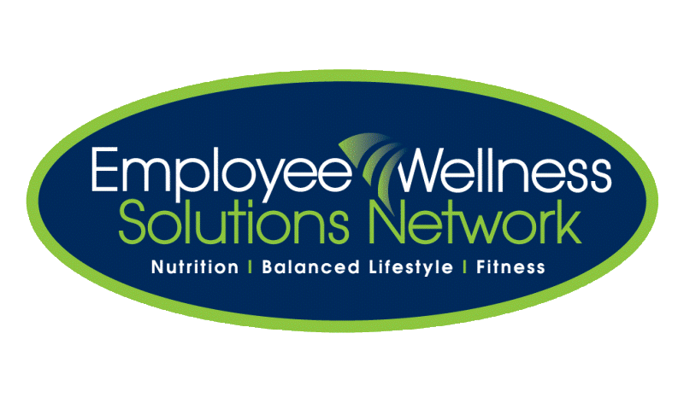


©2010 Employee Wellness Solutions Network - All Rights Reserved.

START DATE: Tuesday January 18th
END DATE: Tuesday February 8th

Help your team WIN!

Which DCAFS Team has the best hand?

