
Day #4 - Low Calorie Eggnog Recipe

Ingredients:
- 2 eggs, separated
- 4 cups skim milk
- 1 teaspoon vanilla
- 1 tablespoon of honey
- 1/4 cup brandy (optional)
- Dash nutmeg

Directions:
Combine the egg yolks and milk in a saucepan. Cook over medium heat until the mixture coats a metal spoon. Cool.
Beat the egg whites until soft peaks form. Add to the milk mixture, then add the vanilla, honey, and brandy (optional). Mix lightly. Cover and chill.
To serve, pour the eggnog into cups and sprinkle with nutmeg. Servings size depends on size of glass used – approximately 4-6 servings.

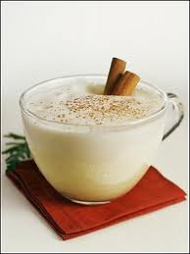




©2010 Employee Wellness Solutions Network –Twelve Days of Christmas. All Rights Reserved. www.EWSNetwork.com

