


Day 10
Seasonal Foods for the Best Summer Eats!

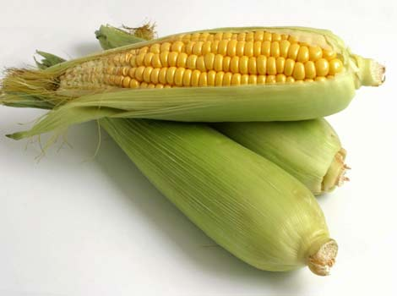
Summer and fall are the best times to get your vitamins and minerals in because a variety of delicious, nutritious fruits and vegetables are in season! Here are some great storing and serving tips for some favourite summer food items!

Food Item | Season | Storing or Serving Tip
Basil | July | Store in refrigerator, wrapped in damp paper towel, for up to three days. Or, dry and store by hanging basil for a week, then store it in an airtight container.
Broccoli | July – late Oct | Keeps for about a week in an open plastic or paper bag. Lightly steam broccoli and toss with olive oil, lemon juice, pine nuts or sesame seeds for a tasty alternative!
Cherries | Late June-early Aug | Choose dark red cherries if you are going to eat them immediately or bright red if you plan to store them for a few days. Simply wash, and enjoy!
Corn | Late July-Oct | Heat converts the sugar in corn to starch, so store your corn in a cool place. Corn can be frozen, husk on, for several months in thick plastic bags. Otherwise, it should be cooked immediately. Cooking tip: soak corn in cold water for three hours, and then grill for fifteen minutes. Add cumin or chilli powder for a unique twist of flavour!
Peaches | Mid July-mid Sept | Peaches are good to go once they are soft to touch. Create a unique side dish by drizzling balsamic vinegar onto peach slices and then grilling face down for ten minutes. Sprinkle with blue cheese and walnuts. Enjoy!
Raspberries | July | Raspberries are extremely perishable and should be used immediately. Store in fridge, and be sure to remove any spoiled barriers first.
Spinach | June – Oct | Store in loose plastic bag at the top of the crisper. Spinach will usually last for up to four days.
Zucchini | July-Sept | Store in a crisper in a perforated plastic bag for up to a week. Bring out their unique flavour by slicing lengthwise and drizzling with olive oil and grilling for four minutes per side.

