


Day 9

Recipe: Beef and Vegetable Kebabs
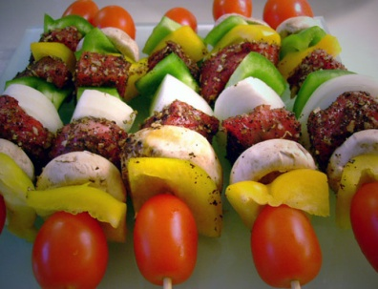
Recipe Tip: Marinating meat before grilling not only adds flavour but also reduces the chance that cancer-causing substances will form on the meat during grilling. Marinating also helps keep meat from burning and charring.

Ingredients
1/2 cup brown rice
2 cups water
4 ounces top sirloin (choice)
3 tablespoons fat-free Italian dressing
1 green pepper, seeded and cut into 4 pieces
4 cherry tomatoes
1 small onion, cut into 4 wedges
2 wooden skewers, soaked in water for 30 minutes, or metal skewers
*Serves 2

Directions
In a saucepan over high heat, combine the rice and water. Bring to a boil. Reduce the heat to low, cover and simmer until the water is absorbed and the rice is tender, about 30 to 45 minutes. Add more water if necessary to keep the rice from drying out. Transfer to a small bowl to keep warm.
Cut the meat into 4 equal portions. Put the meat in a small bowl and pour Italian dressing over the top. Put in the refrigerator for at least 20 minutes to marinate, turning as needed.
Prepare a hot fire in a charcoal grill or heat a gas grill or a broiler. Away from the heat source, lightly coat the grill rack or broiler pan with cooking spray. Position the cooking rack 4 to 6 inches from the heat source.
Thread 2 cubes of meat, 2 green pepper slices, 2 cherry tomatoes and 2 onion wedges onto each skewer. Place the kebabs on the grill rack or broiler pan. Grill or broil the kebabs for about 5 to 10 minutes, turning as needed.
Divide the rice onto individual plates. Top with 1 kebab and serve immediately.

Nutrition Analysis (per serving)

Calories 330 kcal Cholesterol 50mg
Protein 22g Sodium 370mg
Carbohydrate 48g Fibre 4g
Saturated Fat 2g Potassium 620mg
Monounsaturated Fat 2g Calcium 37mg
Total Fat 5g

(Source: www.mayoclinic.com)

