

Day 7
Eating Healthy on your summer holiday

Road Trip! Stay healthy while in the car.
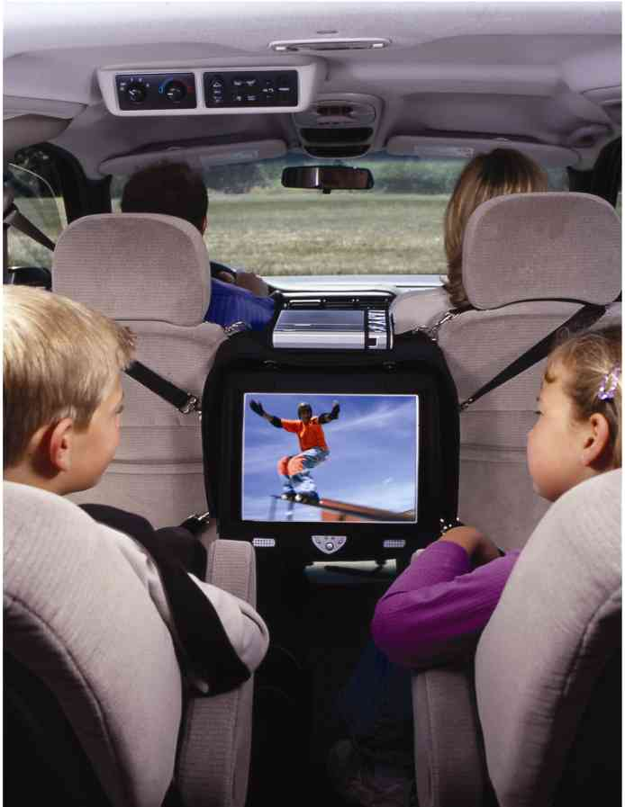

Don’t fall into the fast-food trap; keep healthy snacks and drinks in the car. Kid-favourite treats that travel well include pretzels, bagels, apples, bananas, baby carrots, granola bars and trail mix with nuts and raisins (or any dried fruit). Bringing a cooler with ice packs for drinks, sandwiches or salads will save money and calories! When you have to stop at restaurants for meals the trick is to stick with grilled (not fried) items and salads with dressing on the side.
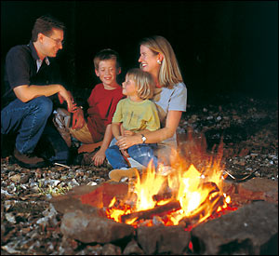
At the Campsite

Just because you are camping does not mean that all you have to eat is hotdogs and hamburgers. There are lots of healthy alternatives to camping classics that are just as fun! To cut out fat and calories you can try turkey or veggie dogs with whole wheat buns or bring homemade turkey or chicken burgers in your cooler. Whole grain breads and peanut butter and jelly are staples to bring along as well for snacks. You can also do low-fat whole grain muffins, cereals, and fresh fruits and vegetables. While camping there is no need to skimp out on flavour, bring along your favourite spices, dried herbs and garlic powder from home!

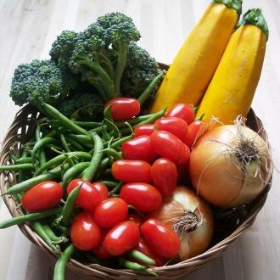
At the Cottage
Once you are up in cottage country, there are great farmers markets around to pick up some healthy fruits and vegetables for your stay at the cottage. Slice them up and make a platter or throw them on the grill for a tasty side dish. You can also keep lunchtime meals simple and healthy with tortillas or sandwiches made with whole grain bread and filled with low fat options like lean deli meats or tuna salad. Add an array of seasonal vegetables in there for extra nutrients. For snacks, keep items that the kids can fix themselves, such as cheese and crackers, prewashed and cut fruits and vegetables, and granola bars. These snacks can easily be packed in a knapsack before you go on a hike.

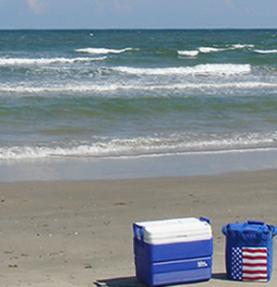
At the Beach
Nothing beats a gorgeous sunny day at the beach in the summer. A picnic is usually the easiest way to go for meals while having some fun in the sand and sun. Using an insulated cooler with ice packs is the best way to keep your food cool, safe and ready to eat. Playing in the water and being outdoors is sure to make your kids very hungry so bring along some nutritious snacks such as nuts or trail mix to give them some energy. For drinks, freeze bottles of water and 100 per cent fruit juice boxes the night before going to the beach. You can use them as ice packs in your cooler before drinking. Also be sure to use some hand sanitizer to wash your hands.

