

Day 6

BBQ Salmon on a Plank with Foccacia and Grilled Veggies

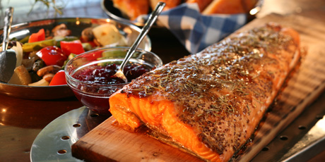

Prep Time: 20 minutes
Ingredients:
Untreated cedar plank
1 red pepper
1 small onion
16 stalks asparagus
2 large mushrooms
Cooking spray (Pam)
1 tsp Mrs. Dash Garlic and Herb Seasoning 1tsb coarse salt (try kosher)
2 pounds (900 g) salmon filets, boneless skinless 1 tsp Mrs. Dash Original Seasoning
1 tsp rosemary leaves ½ cup grainy Dijon Mustard
2 tbsp brown sugar Squirt bottle of water
1 tbsp balsamic vinegar 2 tbsp olive oil
1 loaf foccacia bread

Directions:
- Take out equipment and ingredients.
- The night before: Soak your plank in water until you are ready to cook with it.
- When you get home for dinner: Preheat BBQ to med (approx 350º F).
- Cut pepper and onion into large chunks, heaping into center of veggie basket as you cut.
- Snap off bottom node of each asparagus stalk and discard.
- Break remaining asparagus stalks into 2 or 3 pieces and quarter mushrooms. Place all in basket.
- Spray veggies with cooking spray, sprinkle with spice and place on lower rack of BBQ.
- Rinse the salmon thoroughly under water, then pat dry with a paper towel. On one side only, smear salmon with the salt, spices and mustard then sprinkle on the brown sugar.
- Place the presoaked plank on the grill. Close the lid for a few minutes but keep checking until you see smoke.
- Turn the plank over and place the salmon, rub side up, on top of the plank.
- Move the veggies to the top rack or on one side of the BBQ with reduced heat. Toss often.
- The salmon will be ready when it flakes off easily with a fork (approx 10-15 minutes).
- Squirt the edges of the board if they catch on fire. You will have to keep lifting the lid to check.
- Drizzle olive oil and vinegar in a small bowl for dipping.
- Toss foccacia bread on top rack of BBQ for just a minute while serving up the plates.

(Source: www.mayoclinic.com)

