
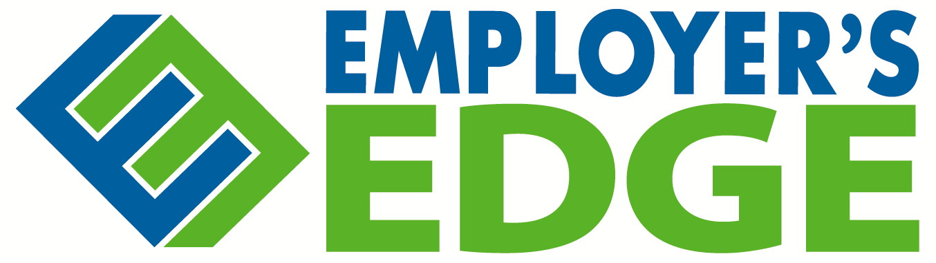
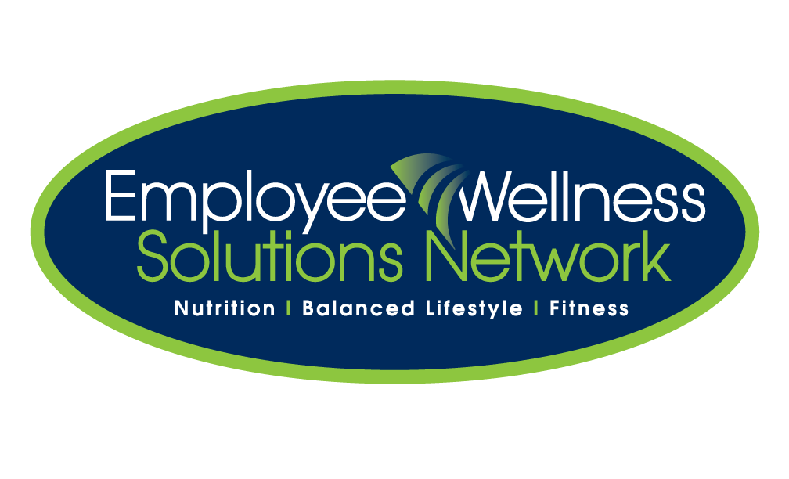
Day 4

Vitamin D, the Sun and You!

Vitamin D is necessary for strong healthy bones and muscles, especially in children and the elderly. Research suggests that Vitamin D may reduce the risk of some types of cancers.

You can get vitamin D from three sources:
- Exposure to sunlight
- Diet
- Vitamin Supplements

A little sunlight can go a long way! The amount of sun exposure needed to produce enough vitamin D depends on:

- Age
- Diet
- Skin colour
- Where you live (those in Northern Latitudes need more sun)
- How strong the sun is

Foods sources of Vitamin D:

Natural Sources | Fortified Sources
Fish (Salmon, Trout, Herring, Tuna)  Egg Yolk  Liver | Milk  Juice  Margarine

You are at higher risk of not getting enough vitamin D if you:
- Are elderly
- Have dark skin
- Don’t go outside very much
- Wear clothing that covers most of your skin
If you are in one of these groups you may want to consult with your doctor about whether you should take a vitamin D supplement year round.

