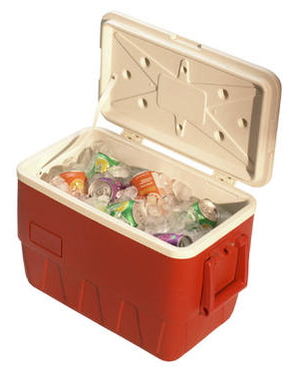

Day 2
Summer Food Safety


The risk of food borne illnesses increases in the summer due to hot humid weather and the increase in outdoor summer activities. When you cook or eat outside on camping trips or days at the beach, you don’t always have access to the safety features that a kitchen has to offer. Here are some ways to keep your food safe to eat this summer!
1. Wash hands and surfaces often to avoid the spread of bacteria.
- Wash your hands with hot, soapy water for at least 20 seconds before handling food, and after handling raw meats or poultry, using the bathroom, changing diapers, or touching pets.
- When camping, or going on a picnic, find out if there will be a source of clean water. If not, bring water for preparation and cleaning, or pack disposable wipes and/or sanitizing lotions and paper towels.
- Always wash raw fruits and vegetables in clean water. You cannot tell whether foods carry surface bacteria by the way they look, smell, or taste.
2. Keep raw foods separate from cooked foods.
- When you pack a cooler for an outing, wrap raw meats and poultry securely, and put them on the bottom to prevent juices from dripping onto other foods.
- Wash all plates, utensils, and cutting boards that touched or held raw meat or poultry before using them again for cooked foods.
- Cook: Make sure you kill harmful bacteria by cooking food until it reaches the proper temperature.
- Don't guess! Take a digital instant-read food thermometer along to check when meat and poultry are safe to eat. The safe temperatures for cooked foods are:
  - 71° C (160° F) for ground beef
  - 74° C (165° F) for leftover food
  - 85° C (185° F) for whole poultry
- Eat cooked food while it's still hot. Remember, bacteria can grow when food is allowed to cool down slowly.
3. Keep cold food cold.
- Perishable foods that are normally in the refrigerator, such as luncheon meats, cooked meat, chicken, and potato or pasta salads, must be kept in an insulated cooler with freezer packs or blocks of ice to keep it at 4° C (40° F) or below.
- Refrigerate or freeze food the day before you pack it for a trip.
- When packing a cooler, put your meat or poultry on the bottom, and then pack food in reverse order, so that the foods packed on top are the ones you expect to use first.
- Keep the cooler in the coolest part of the car, and place it in shade or shelter, away from direct sunlight. Keep the cooler closed as much as possible.
- The simple rule is: When in doubt, throw it out. (Health Canada, 2008)

