
Rooibos Tea

Rooibos Tea

One of the prime reasons that rooibos tea (also called "red tea" for its color) is gaining popularity quickly is because the tea's numerous health benefits. It is a pleasing caffeine-free beverage, derived from the rooibos shrub. Some of the rooibos tea health benefits are: treating digestive problems, skin conditions, heart diseases and also, preventing cancer. Called the new "wonder tea," rooibos has many of the same health benefits of green and white teas while lacking the negative caffeine and tannins associated with those teas.

Health Benefits of Rooibos Tea

- Studies show that rooibos tea helps to fight heart disease and preliminary results in other studies are showing preventative properties as well.

- Rooibos tea contains extremely high levels of antioxidants, powerful substances that fight free radicals in the bloodstream and keep bodies healthy and strong.

- Protection against cancer - The antioxidants in rooibos tea have been shown to increase the productivity of carcinogen-detoxifying enzymes, as well as protecting cell proteins, cell fats, and DNA.

- Improvement of immune system - Rooibos tea's effective combination of antioxidants and important minerals gives your immune system a boost, which means that you'll be able to fight off any illnesses in an efficient manner.

- Reduction of insomnia, tension, headaches and irritability - As a tea with no caffeine, rooibos drinkers have found that enjoying a cup before bed has helped to relax them and relieve any tension to allow for a great night of sleep.

There are many more benefits of rooibos tea ready to be explored, but even if the amazing health perks are not enough to make rooibos tea your favourite tea drink, its sweet, nutty flavour is certain to please.

Source: www.rooibostea.com



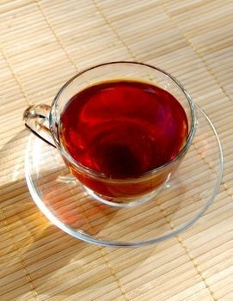

©2011 Employee Wellness Solutions Network – All Rights Reserved.

