Beat the Bug



Proper Hand Washing:

The 6 Step Method

WET HANDS
1

DISPENSE SOAP

2

WHILE LATHERING SOAP SING TWO ROUNDS OF “HAPPY BIRTHDAY” TO KILL ALL GERMS!
3

RINSE

4


TOWEL DRY

5

TURN OFF TAP WITH TOWEL

6

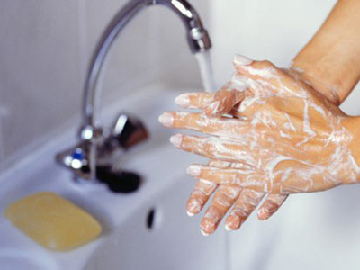
Employer’s Edge challenges YOU to keep your workplace germ free using the 6 Step Hand Washing Method! Beat the Bug this Flu Season!



©2011 Employee Wellness Solutions Network – All Rights Reserved.

