Hand Washing

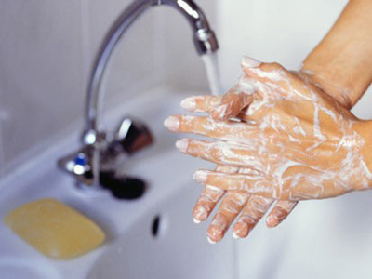
Step 1: Wet Hands

Step 2: Dispense Soap

Step 3: While lathering soap sing two rounds of “Happy Birthday” to kill all germs.

Step 4: Rinse

Step 5: Towel Dry

Step 6: Turn off tap with towel

