Employee Wellness Program

The Employee Wellness Solutions Network wellness program at Waterloo North Hydro involves a variety of wellness initiatives – individual, group (interactive), and awareness programming. There is something for everyone!

Employee Wellness Solutions Network takes a multi-faceted approach to wellness.

1. One-on-One Lifestyle/ Wellness Consultations
By meeting with a consultant one-on-one, you have access to individualized meal planning and exercise routines, personalized strategies for weight loss/maintenance, stress management tools, injury-prevention, back health …. and any other questions (ie: nutrition, physical activity, stress, time management, sleep, etc.) regarding your overall health. Do you want to get back to the gym or workout at home? Get a routine set up. Do you have hypertension or high cholesterol? Learn about some strategies to lower these. Are you diabetic? Gather information about meal planning. Do you suffer from back pain? Learn which exercises are the most beneficial for you. The services for you are endless.

In other words, your very own personal coach / nutritionist / personal trainer / wellness specialist right here on-site!

ON-SITE WELLNESS CONSULTANTS:
Karen Gamble – karen@employersedge.ca

2. Interactive (group) Initiatives
The group initiatives conducted by Employee Wellness Solutions Network may include lunch n’ learns, incentive programs (win prizes!), exercise initiatives, nutrition programs, Work-Life Balance programs, healthy eating programs, lifestyle programming (diabetes, heart health, time management, stress management, etc) and health fairs. The goal of these initiatives is to offer a wide variety of programs with the intent to attract different types of people into the program.

3. Awareness Initiatives/Campaigns
The awareness initiatives include kiosks, posters, bulletin boards, newsletters and wellness challenges.

Here is what a few are saying…

“After joining a fitness club and watching my diet, I felt that there was something missing in my total health program. The executive director talked about the Wellness Program and I thought "It is worth a visit". The consultant was enthusiastic and willing to work with my needs, not fit me into a box. The meeting was encouraging and a plan was put in place. I am proud that I want to be a healthier employee. The consultant has given me realistic goals and I look forward to our next meeting.”

“The Wellness program has come at a crucial time in my life. The consultant has helped me to focus on my goals which are weight loss and stress relief. I truly look forward to my personal appointments, as I receive helpful guidance and support in a comfortable atmosphere. It is wonderful to know that the agency I work for cares enough about me to offer a program that will help me and my colleagues in their personal lives and consequently affect our overall happiness. Thank you EWSNetwork.”

“Very positive approach - through the core exercises provided to me I have noticed a difference in core strength.”

“I realized that my response to stress can determine its impact on my body.”

“I would like to thank Employee Wellness Solutions Network for coming into my life… When I started going to Employer’s Edge, I found out a whole other world of health was waiting for me… I feel fantastic, better than I have every felt before. I attribute all of this to Employee Wellness Solutions Network.”

Q & A’s

Is the Employee Wellness Solutions Network Wellness Program a weight loss program? If weight loss is your goal, we will most certainly provide you with all of the knowledge, tools, support, and motivation you need to achieve your goal. However, we are not strictly a weight loss program. Instead, we take a multi-faceted approach to helping you live a healthy lifestyle.

How do I set up an appointment to discuss some of my health goals? Simply send an e-mail to one of the consultants to request an appointment or to cancel one. They can also be reached at extension 318.

Is it important that I keep my appointment even if I have not done what I said I would? Yes. It is very important to attend your appointment, especially if you haven’t been focusing on your goals. The consultant will help you get refocused and get you back on your way toward success.

There is something offered for everyone. Don’t miss out on this marvellous opportunity. Your organization cares for you and your health – so do we!

Karen Gamble
Founder, Employee Wellness Solutions Network karen@EWSNetwork.com

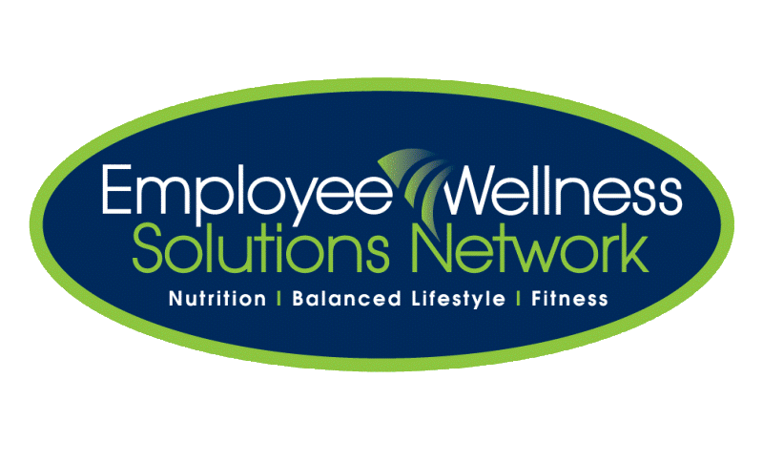
NEW WEBSITE www.EWSNetowrk.com

Do you have a health question or concern?
Log on and check out our easy to use Resource Centre.

Head Office: 502 Old Wonderland Road, London ON I 519-860-0502 I info@EWSNetwork.com I www.EWSNetwork.com

