

This certificate is awarded to

for participation in at least 5 sessions
of the EWSN Extreme Lifestyle Makeover

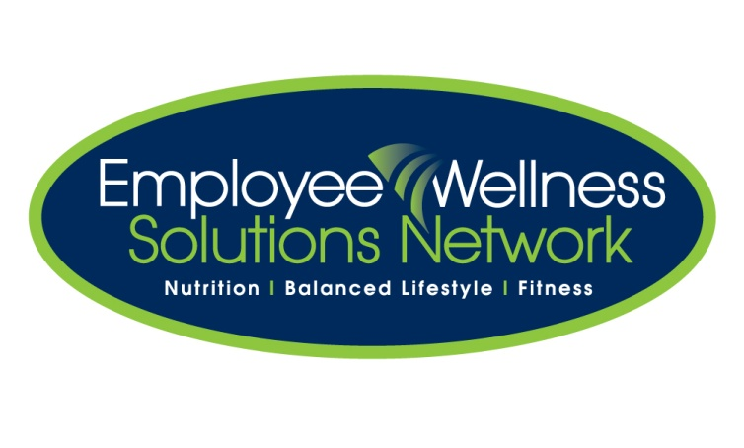
Date
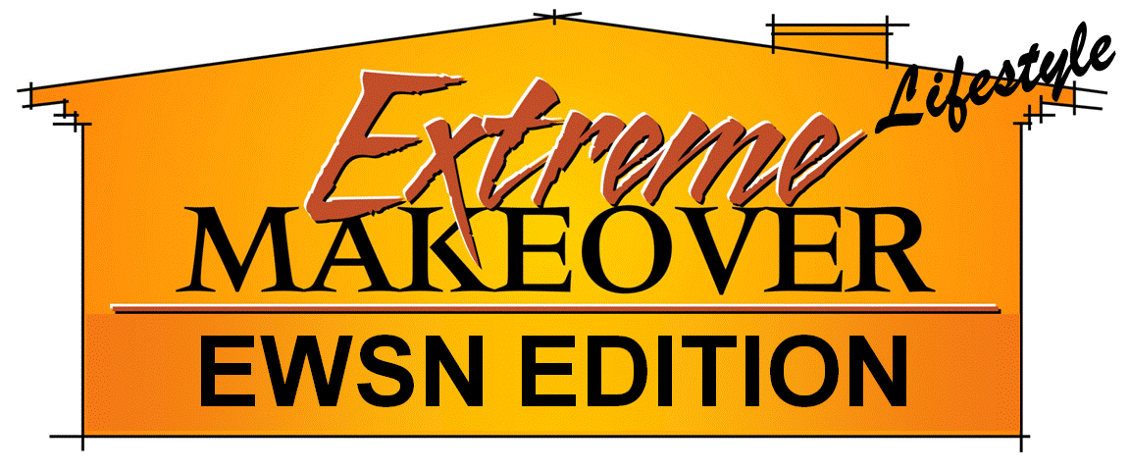

Meaghan Jansen
Certified Corporate Wellness Specialist

