

**The Immunity Challenge:**

**Tips on How to Strengthen Your Immune System**

**Nutrition:**

* Eat at least 5-6 servings of colourful fruits & vegetables daily
* Yogurt contains active bacteria that keeps the gut & intestinal tract free of disease-causing germs. Aim for two 6-ounce servings daily.
* Oats & Barley contain beta-glucan. Beta-glucan has antimicrobial and antioxidant capabilities which are more potent than Echinacea! Aim to include oats and/or barley as at least one of your three daily servings of whole grains.
* Garlic contains allicin, which fights infection & bad bacteria. Aim for 2 cloves per day and add crushed garlic to your cooking several times a week for optimal benefits.
* Fish, such as salmon, mackerel & herring, are rich in omega-3 fats. These fats reduce inflammation, increasing airflow and protecting lungs from colds & respiratory infections. Shellfish is also a good choice as it is rich in selenium. Optimal dosage is two servings per week.

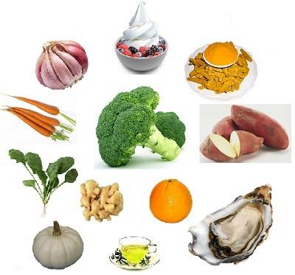

*Sources:* [*www.sparkpeople.com*](http://www.sparkpeople.com)*,* [*www.fitday.com*](http://www.fitday.com)*,* [*www.prevention.com*](http://www.prevention.com)*,* [*www.whfoods.com*](http://www.whfoods.com)

**Did You Know:**

* Excessive consumption of alcohol acts as an immune suppressant. A 1998 article in the journal *Alcoholism: Clinical and Experimental Research* states that alcohol abuse can also lead to immunodeficiency, making you more susceptible to bacterial pneumonia, tuberculosis and other communicable diseases. Moderate consumption of polyphenol-rich alcoholic beverages, like beer or wine, seems to have a beneficial impact on the immune system compared to alcohol abuse or abstinence, according to a 2007 article in the *British Journal of Nutrition*.
* One more reason to quit smoking – smoking and using tobacco products contributes to a host of health problems and has an impact on your immune system, according to an older study in 1983 from the *Medical Journal of Australia*.

**Other Great Immune-Boosting Foods:**

* Citrus fruit – high in vitamin C
* Black or Green tea – high in L-theanine (amino acid)
* Sweet Potato (or any orange vegetable) – contains beta-carotene & vitamin A
* Beef, turkey or beans – great source of zinc
* Drink at least 8 glasses of water per day

**Stress Management**

Stressed out, lonely or depressed? Don’t be surprised if you come down with something! Your body is hard-wired to protect you against threats and it even considers hassles such as a huge workload, taking care of your family and making ends meet, as threats. When stressors are always present and you constantly feel “under attack”, the body’s stress response system stays turned on. Long-term activation of the stress-response system can put you at increased risk of numerous health problems, including digestive problems, heart disease, anxiety & depression. That’s why it is so important to learn healthy ways to cope with the stressors we face in day to day life! Here are some great ideas on how to better manage stress:



* **Laughter** is good for your health! It enhances your intake of oxygen-rich air, stimulates your heart, lungs & muscles and increases the endorphins that are released by your brain. Watch a funny video or have a chat with a friend who knows how to make you laugh!
* **Deep breathing** and learning how to **meditate** can help to centre you and clear away the thoughts that are causing you stress.
* **Journaling** is another great way to rid yourself of the worries of daily life. Write down your worries & fears before you go to bed and once the book is closed, consider yourself done with them (at least for the day).

**Exercise:**

Recent studies have suggested that if you complete moderate exercise just a few times per week, you can drastically reduce the number of colds you get every year. Doctors have found that exercise can boost your immune system by providing a boost to the cells in your body that are assigned to attach bacteria. These cells appear to work more slowly in people who don’t exercise than those that do. Hitting the gym a few times a week and staying consistent will do wonders for your immune system!

**TIP:** Again, moderation is key – working out TOO much can actually harm your immune system. Make sure you are letting your body have rest days if you are working out strenuously!





Remember: **SLEEP** is also key in maintaining a strong immune system. Studies show that people who don’t get quality sleep or enough sleep are more likely to get sick after being exposed to a virus. Lack of sleep can also affect how fast you recover when you do get sick. The optimal amount of sleep for most adults is seven to eight hours of good sleep each night. Teenagers need 9-10 and children need 10 hours or more each night! Create a calming environment in your bedroom and set a good pre-bedtime routine to help you get better quality sleep each night.

*Sources:* [*www.mayoclinic.com*](http://www.mayoclinic.com)*,* [*www.webmd.com*](http://www.webmd.com)*,* [*www.fitday.com*](http://www.fitday.com)*,*